January 016 .2024
Facebook: https://www.facebook.com/groups/101542159983749
Website: https://www.nspeidiocese.ca/ministries/diocesan-environment-network
Email: endionspei@gmail.com
Pray with us every Monday Evening at 7 pm. Email us for the zoom link.
“To strive to safeguard the integrity of creation and sustain and renew the life of the earth”.
SOOF Soup Sunday
- Date: Sunday, January 21, 2024
- Time: 12pm - 3pm
- Location: Centerlea Community Hall (3495 Highway 201, Centerlea)
- Details: Join the SOOF Annapolis team for a free lunch of hot soups and bread! We'll be hosting a conversation about the (proposed) Goldsmith Lake and Beals Brook Wilderness Areas.
- Registration: The event is free (donation to the Hall is appreciated) but we do ask people to register so we know how much soup to make: https://link.arlingtonforestprotection.ca/register
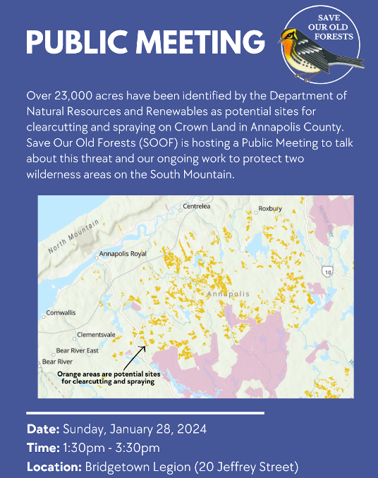
Public Meeting
Date: Sunday, January 28, 2024
Time: 1:30 - 3:30pm
Location: Bridgetown Legion, 20 Jeffrey Street

About: SOOF is hosting a Public Meeting to talk about potential sites in Annapolis County that have been identified for clearcutting and spraying and our ongoing work to protect two wilderness areas on the South Mountain.

Please note that this is not a SOOF Soup Sunday event and there will not be a free lunch served at the Public Meeting.
January 14, 2024 • 2nd Week in Ordinary Time
“Speak, Lord, for your servant is listening.” –1 Samuel 3:9. Like Samuel, are we attentively listening to the calling of God? Pope Francis explains in Laudato Si’, “We are called to be instruments of God our Father so that our planet might be what he desired when he created it and correspond with his plan for peace, beauty, and fullness.” This week, start a habit to become a better instrument for God. Collect rainwater to water indoor plants, eat less meat, combine trips to reduce car/gas usage, or take other steps to care for our common home.
© The Pastoral Center / PastoralCenter.com. All rights reserved.

With thanks to our Advocacy Editors, Eva Evans and Jesse Hamilton
Avaaz - Stop Deep-Sea Mining
More than half a million people have signed this petition asking Norway to not destroy the ocean floor, poison our oceans, and bring incalculable harm to marine life. Sadly, Norway just became the first country to back deep-sea mining despite environmental concerns. The government has agreed with two opposition parties to proceed with plans of exploration of deep seabed mining in Norwegian waters. The area that will be opened is larger than the Netherlands, South Korea, and Greece combined. More than 800 marine scientists and policy experts from 44 countries have called to pause deep-sea mining plans, and quite understandably since it could lead to irreversible damage. Later this year, the International Seabed Authority will meet again to finalise rules on deep sea mining in international waters. Norway stands to be a guiding post in how our ocean’s future will unfold. Join in with people around the world who are continuing to urge Norway to rethink the destruction and instead say no way to deep-sea mining.
Take Action: People in the parishes are dying (only.one)
This petition is about refusing to let fellow human beings and our natural environment be poisoned by industrial giants. Cancer Alley is an area in Louisiana that lives up to its name. A shocking concentration of toxic industrial facilities can be found here, next to school playgrounds, backyards of homes, alongside critical water sources, and many other community places. This has been a death sentence for residents, and despite this tragedy and decades of environmental racism, two more massive industrial projects are under consideration. The DG Fuels plant could emit known carcinogens into the air and water. The Air Products' plant would also emit toxic pollution and store all this toxic gas beneath the local lake, which the community is against. Any leak or explosion would do irreparable damage to people and the environment. Please support the struggle happening here by telling officials no to the toxic harm and yes to a healthier, sustainable path forward

Join the movement to #BanPrivateJets - Greenpeace International
Private jets are the epitome of social and climate injustice. In just one hour, a single private jet can emit two tonnes of CO2. The global average energy-related carbon footprint is about 4.7 tonnes of CO2 per person in a year. The reality is a privileged minority flies around without restriction, while 80% of the world’s population has never been on a plane and is most heavily impacted by the climate crisis. Private jet emissions have been increasing, even more than doubling in some places. Add your name to call on governments to get onboard with tackling climate injustice and inequality.
Sign now: Banking on Amazon Destruction (stand.earth)
Amazon deforestation has been hitting record highs, while oil & gas extraction continues to increase deforestation and forest degradation in this intricate home to so much biodiversity. Imagine instead an Amazon-wide exclusion policy that uplifted interconnecting commitments around deforestation, biodiversity, and Indigenous People’s rights. This is possible, but banks need to stop pouring investment and financing into the oil & gas companies that are causing this destruction. JP Morgan Chase, HSBC, Deutsche Bank, Goldman Sachs, and Citigroup are all banks scoring “F’s” and are at “very high-risk” of funding the destruction of the Amazon. These banks have deforestation policies and screening processes, yet they find policy loopholes to keep them in business with companies involved in corruption, human right’s violations, and biodiversity loss. Use this petition to tell banks to stop financing oil expansion in the Amazon through an exclusion policy for the whole region.
Windfall Tax on Fossil Fuel Companies (Greenpeace)
In 2023 fossil fuel companies made huge profits all the while driving up inflation. While Canadians struggle to put food on the table, and meet their basic needs, oil and gas companies are posting sky-high profits. The UK, Spain, Italy and the EU have already announced their plans for Windfall Taxes on fossil fuel profits to bring immediate relief to people struggling with soaring costs. But so far, Canada’s Ministry of Finance is not following their lead. For extra info read:
https://www.nrdc.org/bio/zanagee-artis/oil-industry-netted-billions-profits-despite-global-price-dip

Windfall Tax on Fossil Fuel Companies (Greenpeace)
In 2023 fossil fuel companies made huge profits all the while driving up inflation. While Canadians struggle to put food on the table, and meet their basic needs, oil and gas companies are posting sky-high profits. The UK, Spain, Italy and the EU have already announced their plans for Windfall Taxes on fossil fuel profits to bring immediate relief to people struggling with soaring costs. But so far, Canada’s Ministry of Finance is not following their lead. For extra info read:
https://www.nrdc.org/bio/zanagee-artis/oil-industry-netted-billions-profits-despite-global-price-dip

With thanks to Claudia Zinck

Ghost Gear
I often wondered about ghost gear. Some nets are cut or broken and let sink with the fish in the nets sometimes. How long does it take for materials to break down? What happens to nets and gear? Having grown up in a fishing village, my mind still hears the very old explanation. “Oh, it just goes to the ocean floor and gets covered with the next thing that falls on them. It disappears soon.”
Ah, NO!!!!!! Really? NO!!!!!!!!!!!!!!!
See the net and buoys in the picture. When I started my walking routine on November 1st, what looked like a cork line and buoys had washed up on shore. I have no idea when it came ashore. Since then, we have had hurricanes, Nor-easters, snow, rain, and wind galore and there it stays. Some days it floats with a high tide, but it never leaves that spot. How much gear is snagged on something in our ocean?
The next picture is a 30-foot or more pipe that washed ashore near it. I even mentioned it to several people hoping someone might want it for a project and salvage it. None did. One day after a storm it was gone, Two days later, I walked Jazz to our wharf and there, on the sandy beach, lays the long pipe.
That pipe travelled a km by water, got caught in the current at the end of the wharf and just swirled into our cove. It’s the lobster fishing season here. Those boats are out way past dark but even their lights wouldn’t pick up a black pipe on the water. That pipe would have floated in the way of a half dozen boats a day.
These are just two tiny points about fishing gear. Want to learn more? Take a look here.
https://www.coastalaction.org/ghost-gear.html
https://www.worldanimalprotection.ca/sea-change-campaign-tackling-ghost-fishing-gear?ea.tracking.id=google_grant&utm_source=google_grant&utm_medium=google_grant&utm_campaign=google_grant&utm_content=global%20ghost%20gear%20initiative&gad_source=1
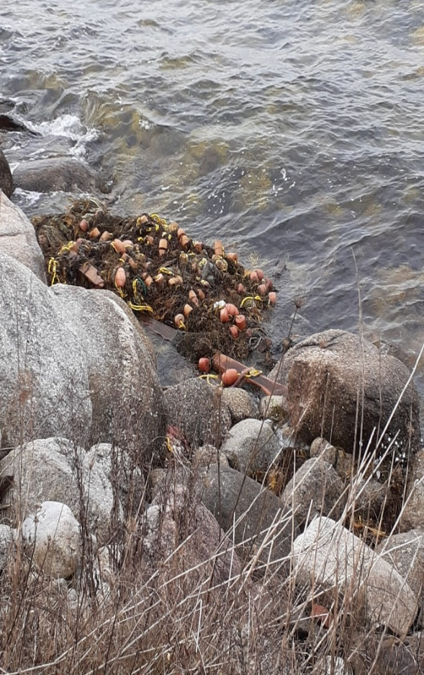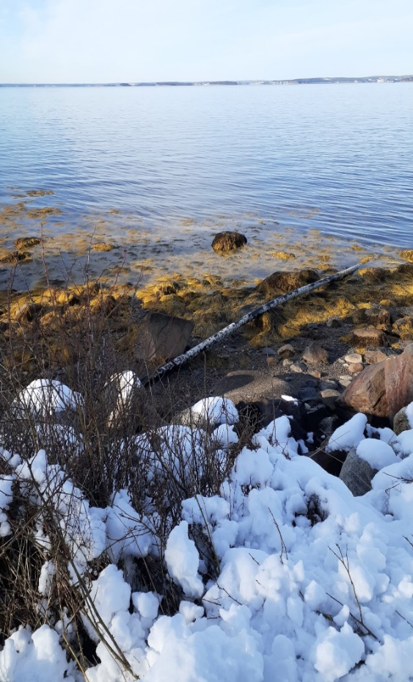
Climate Change

Just another way to know climate change is real, I got this message from my former manager in Regina.

“Winter in Regina is a lot different this year, we had a completely brown Christmas, and we have virtually no snow which is unheard of out here. It was +1 on Christmas day, so we did not need heavy coats or boots. My husband predicts we will have a huge storm that will make up for this…. I sure hope he is wrong.”

This week the weather specialists are telling Regina to stay indoors as it is getting close to minus 50.

Gardening – Something to think about
Some farmers are creating a flower belt in their fields of produce to help pollinators feed as they move about.
The picture shows a big swath of flowers in the middle of a field. Why can’t we plant a row of flowers in our veggie gardens?
There are books written on the value of planting edible flowers in veggie gardens. Even if we can’t eat them, they help the pollinators and brighten any day. Do an easy plant like nasturtiums that you can easily collect seeds for another year.
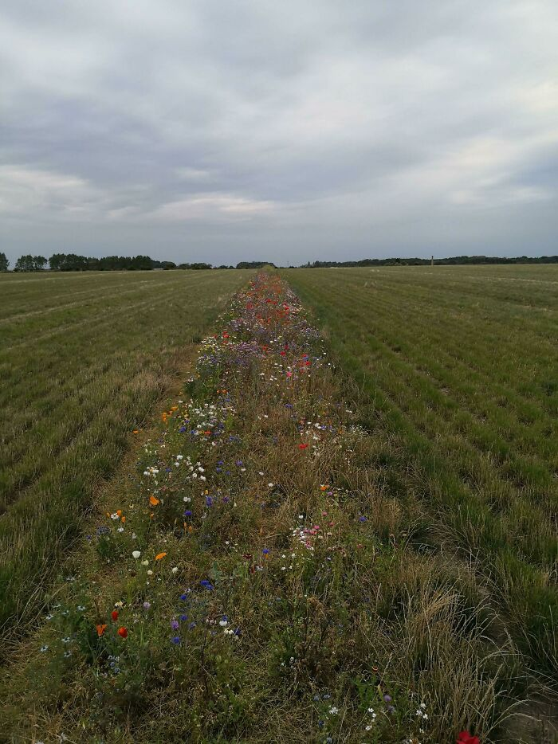
Image credits: Reddit/NulloK
Craft – Calendar envelopes
You might be lucky enough to have a few paper calendars ready for paper recycling. I always saved mine so the kids could make posters with the pretty pictures. Another use is to make your envelopes.
Take a pretty calendar page. Decide which part of the picture you want for the envelope front. Then make the rectangle into a square by folding the short side to the long side and cutting off the excess.
Take each point of the square and fold it to the middle. You may have to wiggle the fold lines according to your comfort for the sides to overlap. If using tape, you can secure all 3 bottom sides with one piece of tape. If glueing, you may need to make your folds deeper for an overhang to glue.
These envelopes are great for storing small things for scrapbooking. Use a plain piece of paper to cut a rectangle large enough for the address, when using them in the mail.

+

