January 09.2024
Facebook: https://www.facebook.com/groups/101542159983749
Website: https://www.nspeidiocese.ca/ministries/diocesan-environment-network
Email: endionspei@gmail.com
Pray with us every Monday Evening at 7 pm. Email us for the zoom link.
“To strive to safeguard the integrity of creation and sustain and renew the life of the earth”.

The Clean Foundation is looking for help developing new workshops and resources on Climate Anxiety. They will have Teacher as well as Student and zyouth focus groups . Find out more here: https://mailchi.mp/3e7579cc97f2/inspire-environmental-change-this-spring-6685947?e=2e45289392
The Clean Foundation are also offering new Climate Action workshops and have Climate Action Grants for Grades P-12. Please see the link above for more info.
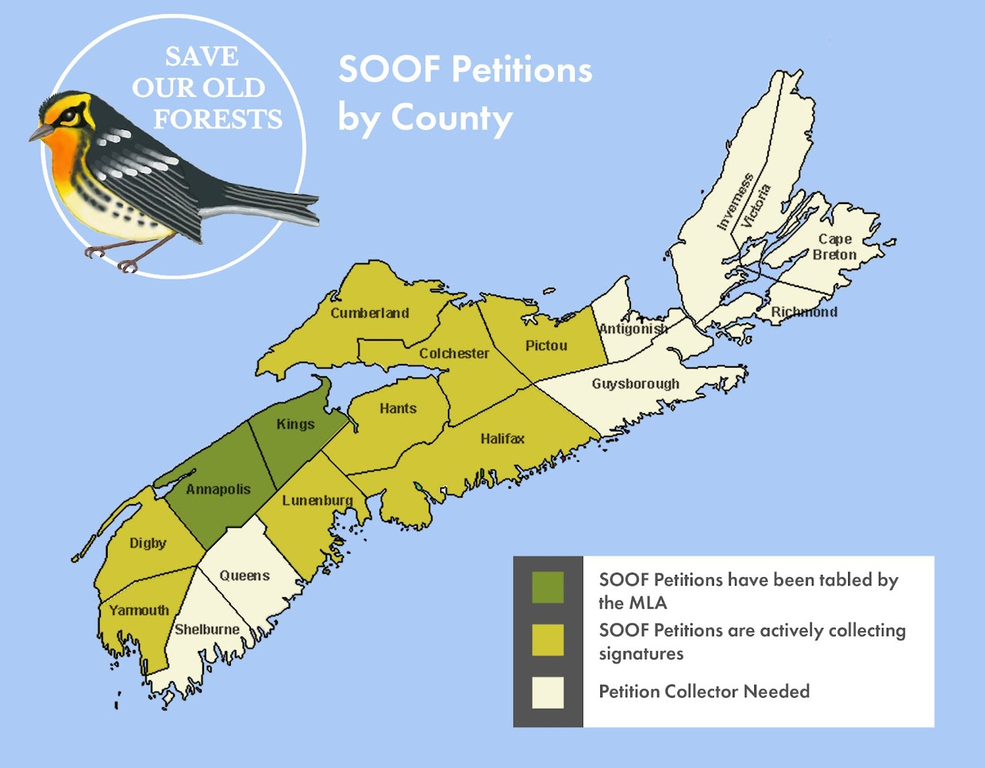
https://www.arlingtonforestprotection.ca/soof/petitions

January 7, 2024 • Epiphany
“Then you shall see and be radiant; your heart shall thrill and rejoice because the abundance of the sea shall be brought to you.” –Isaiah 60:5. Approximately 3 billion people worldwide rely on seafood as an essential source of nutrition. Sadly, wild fish populations are declining rapidly due to overfishing, poor resource management, and climate change. Before buying or ordering seafood, check the Seafood Watch consumer guide to help you identify the most sustainable choices: SeafoodWatch.org or download the mobile app. © The Pastoral Center / PastoralCenter.com. All rights reserved.

With thanks to our Advocacy Editors, Eva Evans and Jesse Hamilton
Tell pensions to put people before profit. (stand.earth)Nearly 30% of fossil fuel stocks are held by pension funds. This means our pensions, tax dollars, and retirement funds are propping up fossil fuel companies who are causing massive pollution, the climate crisis, and violating Indigenous rights. This petition is asking for help to change this; for people to matter more than profits. Investing in fossil fuels is not only bad for the planet and our future, but it’s a risky investment. Add your name to proclaim that you want your money to help, not harm.
Support the KlimaSeniorinnen in their fight for Climate Justice - Greenpeace International
Switzerland’s KlimaSeniorinnen are taking the government to the European court of human rights for doing too little to tackle the climate crisis. This is the first climate change case the European Court of Human Rights has ever examined and the Court will determine if states have duties to mitigate the climate crisis to safeguard human rights. KlimaSeniorinnen are more than 2000 senior women who suffer especially from increasing and more intense heat waves and don’t have time to waste. They formed an association together to take their state to court for doing too little to prevent climate change, but after exhausting all national options they applied to the European Court of Human Right. They say Switzerland must do its share to keep global heating below 1.5ºC. What do you say about the potential here to protect present and future generations from further climate destruction? These women are literally changing the world! Sign your name to support them and this movement.
Tell insurers to drop Trans Mountain (stand.earth)
18 companies have now abandoned the Trans Mountain project. It must secure insurance in order to proceed with its controversial tar sands pipeline, and without it, the pipeline cannot go ahead. This provides an opportunity for a wave of public pressure to convince any remaining insurers to follow suit and un-insure the pipeline! Trans Mountain’s insurers need to respect Indigenous rights and the climate too. The petition is asking publicly for them to drop this risky project.

Petition to Fed. Gov't to stop funding Trans Mountain (Dogwood)
Tell Finance Minister Chrystia Freeland and your own MP to stop misleading the public, stop throwing good money after bad – and invest in clean energy and green jobs that will build the resilient economy of the future instead. The world has changed since Trans Mountain was approved. Federal agencies and industry insiders say this project is no longer needed and will lose money for Canadians.

Petition from Amazon Watch to Banks Financing Oil Exploration
Autonomous Indigenous nations of the Peruvian Amazon have united to denounce oil exploration and exploitation on their territories and call for no new financing for oil company Petroperú. Financial institutions are complicit in rights violations and environmental destruction on Indigenous territories through their financing of Petroperú, and affected communities are organizing in resistance. Send a prepared email to bank executives and representatives demanding a public commitment to end financing of oil company Petroperú!

Petition to Protect Wild Salmon (David Suzuki)
Time is running out for wild salmon. Wild salmon have a fundamental role in First Nation communities and in ecosystems. With climate change already having significant impacts on their fitness, habitats and prey, it is paramount to protect them from risks within our control. One of these risks are open-net pens. Many independent, peer-reviewed studies have shown that the risk of disease and parasite transmission from farmed to wild salmon is simply too great for the two to coexist - Pacific salmon recovery requires the removal of open net-pens from wild salmon habitat.

With thanks to Claudia Zinck
Memories
My cousin Carroll didn’t know it, but she gave me one of the best gifts I could have received this Christmas. She has diaries from the lady I called Aunt Florrie (my grandfather’s brother’s wife). Carroll has been sending me samples.
Florrie Zinck was the centre of so much of community life here. I remember at least stories (though I can see myself playing under the quilt frames) of how Aunt Florrie used any excuse for a party. She was especially known for her mat hooking or quilting parties. She may have fed everyone, but she had 6-10 women working on a mat or quilt. The men would come by the house at suppertime to get their plates. They would gather on the back closed-in porch where a second stove kept them warm. After the meal, they would walk their wives' homes. These were considered big events.
Her diaries tell of an earthquake in 1959 in our part of Lunenburg County that rattled dishes in the cupboards. Daily news tells of more earthquakes.
The hailstorm in September 1939 broke windows, blew off chimneys and in this case, ruined the “cabbage coop”. What is a cabbage coop you ask? You dig a hole in the ground maybe four feet down, usually 4 x 6 feet or bigger, and build a roof over it. Cabbage would be kept in it along with buckets of sauerkraut and root veggies.
The sea storm in 1956 did much the same but in our family, it took away the family’s salt fish for winter. It would have been cold lean times after these storms.
At least the men could have gone hunting. There would be black ducks on the ice claps. Deer was more plentiful in the backwoods and every kid over seven years of age had rabbit snares.
The diaries taught me that bad weather is not just the 2024 climate change issue. Sometimes it is just a bad storm. Times are just as lean now. I worry that boys (or girls) these days have not learned to hunt as they did in my youth, be that good or not. Winter, cold and hunger, were just as much a concern then as now but somehow, we seem to have fewer resources today.
We planned for winter all year long. Cellars were full. The barrel of flour had to last a whole winter. Sugar was used carefully. Still, we ate well.
We planned for times with less work. Much to my grandmother’s horror, just before Christmas the fishing nets were pulled straight through the front door and up to the third-floor attic. Although still cold, it was warmer than the sheds for Grandad to mend his nets.
For the women, every bit of mending was caught up along with the extra ironing. Clothes were made. Mats were hooked and laid to cover every inch of the living room floor. The cot back of the stove grew higher as the blankets were patched or made and laid there till needed.
Looking back at those times, they seem so harsh. It seemed like endless work just to survive. When I look at the news these days, I think we were the lucky ones. We had a roof over our heads, food in the cellars, warm clothes and a wood stove pumping out the heat. How many people these days do not have those luxuries?
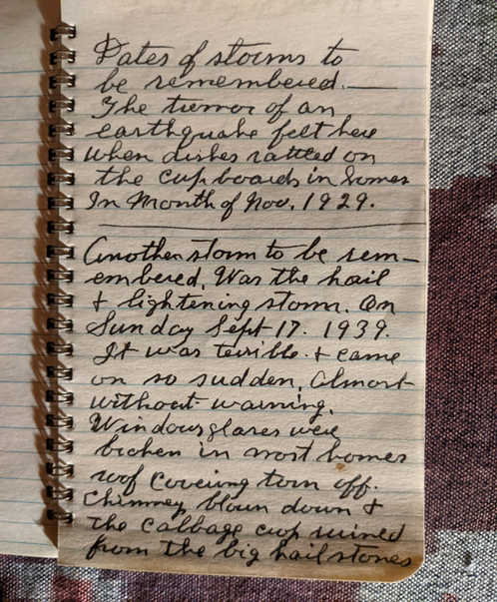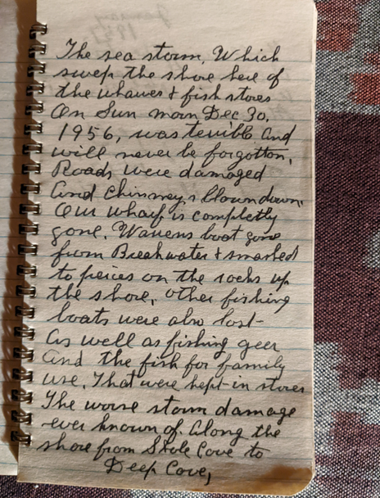

Gardening
I know. It is January! Why even think of gardens now?
This is when I start planning my planting kits. I applied for another grant in December to help pay for supplies for the kits. Although churches cannot get grants to maintain buildings, they can, at least in our municipality, get a councillor's grant for “community” projects. Planning to put out (this year) 250 kits, makes it a community project. Ask your councillor or warden if such a thing exists where you live. It’s a good time to plan Earth Day now.
One more item. Remember me mentioning how wind erosion took good topsoil out of my garden boxes? I found another answer to help that, even if too late for this year. Seaweed! While walking Jazz recently I see large quantities of seaweed on our beach. Spreading seaweed on top of the garden boxes provides fertilizer and lessens erosion. It’s an old trick, but one I had forgotten.
Cleaning
This is the best time of year to get a few extra jobs completed.
I would like to suggest looking at flylady.net where (if you want to carry it that far) the entire year would be mapped out as to what to work at each day for a clean house. I’m not that good. It is a great guide though.
I have decided this year, especially since we now own dehumidifiers, that all those tubs of Christmas ornaments, weighing 20-40 lbs. each, that I push or pull from a ladder to my attic, are going to the basement. I want to reduce to six tubs on a shelving rack. (Maybe eight.) (Come on, I still have my mother’s 1940 bells she bought at Woolworth’s on Barrington Steet for eight cents) (You don’t want to know what else has been collected)
Choose even one corner of one room and dive in. It can’t be worse than mine, but together we can make things a bit more tidy.

Newspaper Fire Starters Craft
The first week of January I always had my Messy Church make fire starters. If people don’t have wood stoves, these can be tucked away for campfires. You just need either newspapers or flyers, a pencil and bits of tape.
Spread a sheet of newspaper open (either the half sheets but even better whole two-page sheet)
Starting at one corner, roll the newspaper around the pencil. When finished, loosen your roll a bit so the pencil can slide out easily. Use a bit of tape to keep the paper shut.
These will quickly turn into swords if working with kids.
Cut the paper where they are joined with tape. Bundle 10-12 with a piece of string or leftover ribbon from Christmas.
Get the kids to give them out at the end of a service.
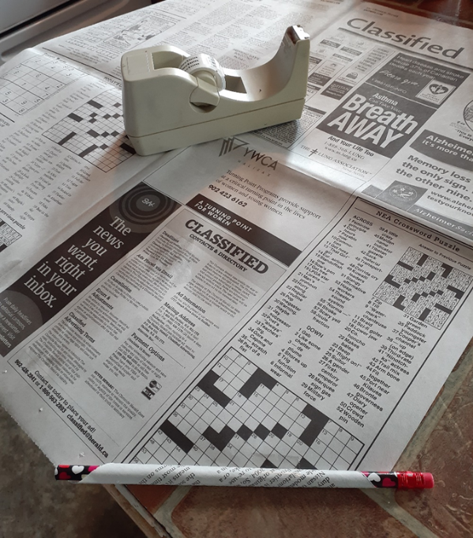
Something to Eat
We were alone here on the 25th, so I wanted to make my daughter’s overnight slow-cooker breakfast casserole. All the recipes asked for 12 eggs. We didn’t need that big a meal. I cut down the recipe, but it still made 2 meals for two.
Breakfast Casserole
6 eggs
Half a pack of bacon cut small and pre-cooked lean
(Together or alone) half a pack of sausages, again, cooked lean
1 cup ( up to 2 cups )of hash browns according to their size
Salt, pepper and finely chopped onion if you can use them
Mix them all and put them in a slow cooker for 6-8 hours
I put my mixture in the oven close to midnight. Jazz woke me at 3 for a run outside and they were starting to firm up. At 6 AM they looked cooked, but I turned the cooker to warm till we ate a couple hours later. So easy, so good
Till next week, Grandma is sending hugs.

+

