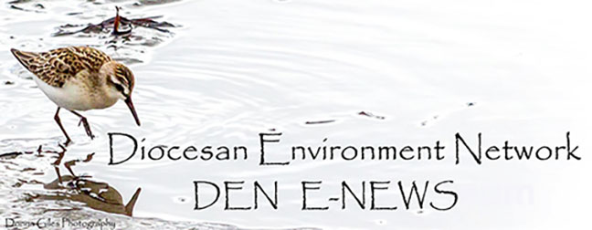December 05. 2023
Facebook: https://www.facebook.com/groups/101542159983749
Website: https://www.nspeidiocese.ca/ministries/diocesan-environment-network
Email: endionspei@gmail.com
“To strive to safeguard the integrity of creation and sustain and renew the life of the earth”.

The Second Sunday of Advent – December 10. 2023
Image from: https://www.ministrymatters.com/all/entry/3267/worship-connection-november-28-2021
December 10, 2023 • 2nd Week of Advent
As you buy gifts and prepare to wrap presents for Christmas this year, think about the impact of wrapping paper on the environment. Not only are trees cut down to make it, but it usually can't be recycled and ends up in the trash instead. Landfills in the United States are filling up at almost two a day! Choose an alternative this year: old newspapers or magazines, other re-used paper, cloth napkins, etc.
© The Pastoral Center / PastoralCenter.com. All rights reserved.
From Mother Susan at The Contemplative Cottage
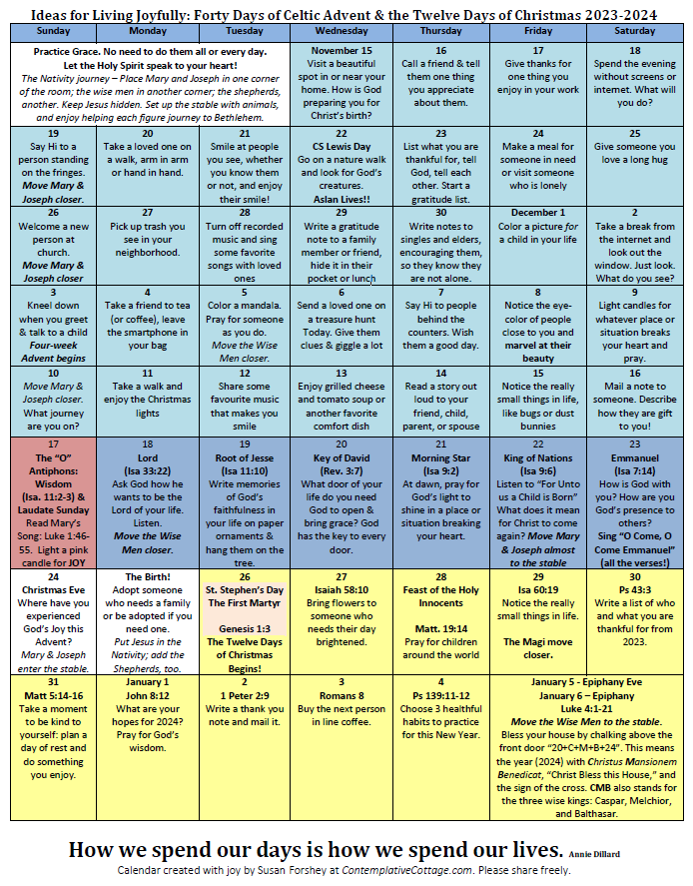
https://contemplativecottage.com/celtic-advent-calendar/

