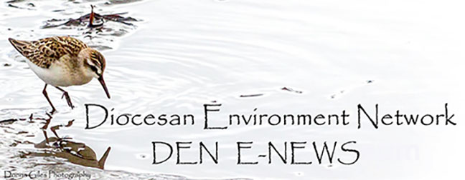November 21. 2023
Facebook: https://www.facebook.com/groups/101542159983749
Website: https://www.nspeidiocese.ca/ministries/diocesan-environment-network
Email: endionspei@gmail.com
Pray with us every Monday Evening at 7 pm. Email us for the zoom link.
“To strive to safeguard the integrity of creation and sustain and renew the life of the earth”.
The Nov. 21st and 28th DEN Enews will be our last full newsletters until after the New year. We will only be offering short reflections with tips for each week of Advent.

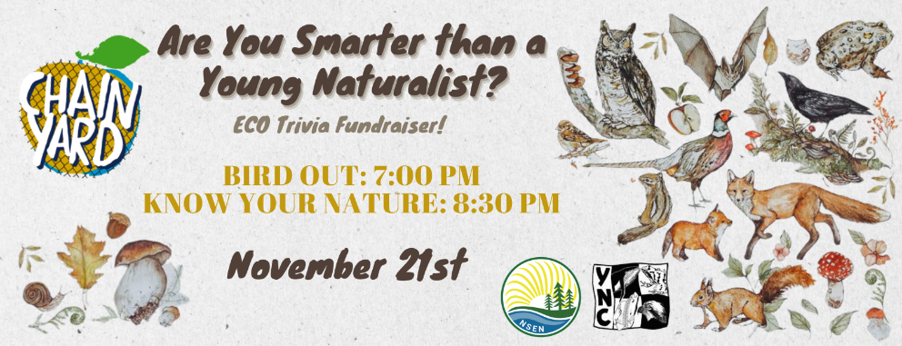
Sounds like fun! Click ion the link for more info: https://nsenvironmentalnetwork.app.neoncrm.com/np/clients/nsenvironmentalnetwork/event.jsp?event=109&&secureIdCustomer=1&fbclid=IwAR1M6aD8nLN7mIwDAzSlbvNg6EsC2ibVFg-WA7DMX825FBOMxVokWrLoymI

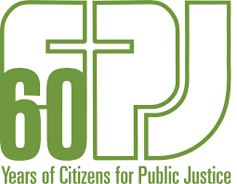
Laudate Deum: Eco-Spirituality in Action webinar
For more information:
https://cpj.ca/events/laudate-deum-webinar/
Faithful Ventures: Introduction to Social Enterprise and Q&A
Date: November 30, 2023
Time: 12:00 noon
Link: https://us06web.zoom.us/j/83755409545
In our first session, we delved into the concept of social enterprise and explored how our church community can create a positive impact while ensuring financial sustainability. Now, it’s time to hear from you!
In the upcoming webinar, Lisa Lowthers will review some key concepts of social enterprise, and will then focus on addressing your questions. Lisa is the Director of Social Impact at Common Good Solutions. Whether you're curious about the practicalities, potential challenges, or specific ways your church can embark on this journey, this session is your opportunity to get personalized answers.
How to Participate:
1. Click on the link on November 30 at noon.
2. Bring your questions, thoughts, and ideas about social enterprise.
Why Attend:
- Gain deeper insights into the concept of social enterprise.
- Receive personalized answers to your questions.
- Explore how your church can actively contribute to positive change.
Your participation will shape the direction of our potential social enterprise initiatives. Let's come together, learn from one another, and explore the possibilities of making a lasting impact.
If you have any questions or require further information, please feel free to reach out to me at FinancialController@nspeidiocese.ca.
Lawrence Roche CPA, CA
Financial Controller | Diocese of Nova Scotia and Prince Edward Island

If you are thinking ahead to Advent, this is an interesting resource from Eco Congregation Scotland called Advent - Keep Awake. It includes short videos for each day in the season.
https://www.ecocongregationscotland.org/advent-keep-awake/

This Advent, commit to Simplicity
This website offers you the opportunity to sign up for the Simplicity Challenge. You will receive regular emails and an Advent calendar for daily inspiration to live simply and heal the earth.
https://ignatiansolidarity.net/advent-simplicity-challenge/?utm_source=ISN+Updates+List&utm_campaign=66c051db25-INSTITUTIONAL_UPDATE_072220_COPY_05&utm_medium=email&utm_term=0_f721035495-66c051db25-257417536&goal=0_f721035495-66c051db25-257417536&mc_cid=66c051db25&mc_eid=01633dc060

Creation Care Tips 2024
Published by The Pastoral Center, this $12.00/ parish booklet offers “Weekly Prompts to Care for Our Common Home”. It is provided in Word of PDF formats and is free to disseminate within your parish. https://pastoral.center/creation-care-tips-2024

How the Longing of Advent Points Us Toward Creation Care
A quick Google search for “Advent & Environment” or “Advent & Creation“ will offer many resources. Here is one blog with reflection and questions on how we might bear witness.
https://www.faithward.org/how-the-longing-of-advent-points-us-toward-creation-care/

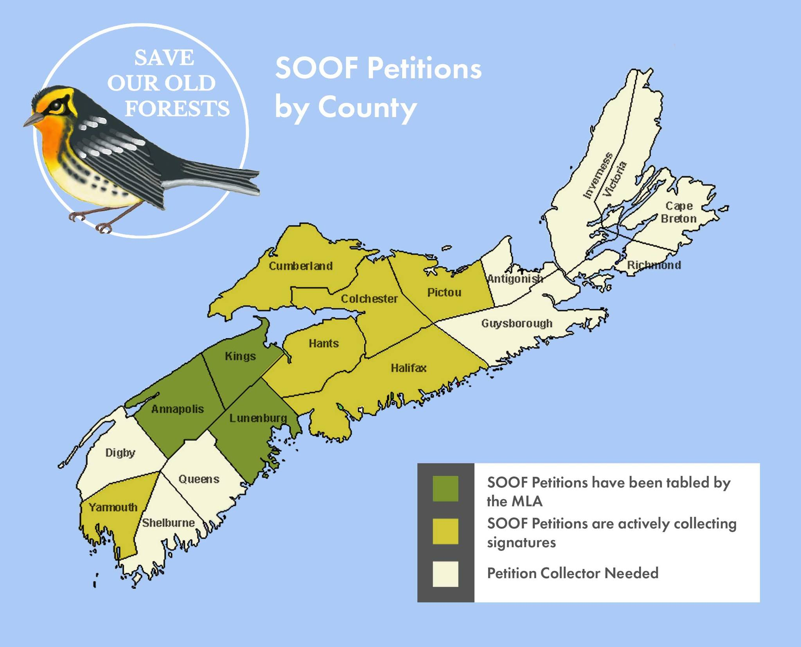
From the Save Our Old Forests Facebook page:
It's pretty amazing to see how many Counties have jumped on board to the Save Our Old Forests campaign since our initial launch of just the Annapolis County petition in March 2023 at the Bridgetown Legion!
As you can see from the map though we still need help to spread the campaign and petitions across Nova Scotia. We are actively seeking people to volunteer as Petition Collectors in Digby, Queens, Shelburne, Guysborought, Antigonish, Inverness, Victoria and Richmond Counties.
We are also looking for volunteers to help as Signature Collectors in Cumberland, Hants, Colchester, Pictou, Yarmouth and Halifax Counties.
By the way we aren't expecting people to go door to door to collect signatures! We find talking with friends, family, neighbours and co-workers, or talking to the owner of the local coffee shop more effective than knocking on strangers' doors. Each petition has 18 signature lines and they fill up pretty quickly!
If you're interested in volunteering in your County please comment below or send us a DM!
#saveouroldforests
https://www.facebook.com/SaveOurOldForests
PETITIONS: All of our active petitions are available on our PETITIONS page
Check out the latest news and see upcoming events on their website, Facebook and Instagram pages
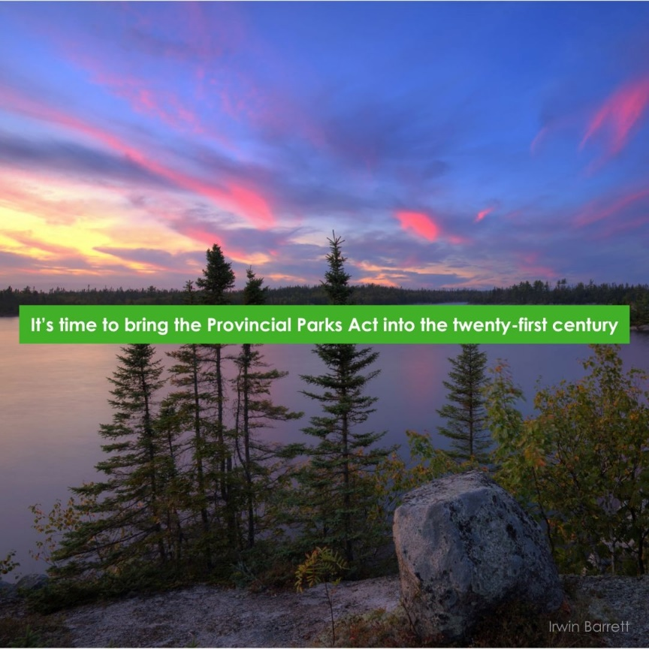

Help bring the Provincial Parks Act into the 21st century
Over the past five years, there have been three proposals to co-opt our provincial parks for private golf courses — and the Provincial Parks Act is so outdated, broad and vague that this could happen again tomorrow. Nova Scotians deserve the peace of mind that updating the Provincial Parks Act would offer, so communities never have to go through this again. Click the button below to tell the Houston government that you’re counting on them to amend the act!
https://ecologyaction.ca/tell-province-amend-provincial-parks-act

From their website: CLIMAtlantic facilitates access to data and information that supports adaptation to climate change in Atlantic Canada through collaboration, networking, and partnerships. https://climatlantic.ca/
For funding opportunities: https://climatlantic.ca/tools/funding-opportunities/
The Adaptation Library is a collection of publicly available tools and resources relevant to climate change:
https://climatlantic.ca/tools/adaptation-library/#/options/

.

