October 17. 2023
Facebook: https://www.facebook.com/groups/101542159983749
Website: https://www.nspeidiocese.ca/ministries/diocesan-environment-network

Email: endionspei@gmail.com
Pray with us every Monday Evening at 7 pm. Email us for the zoom link.
“To strive to safeguard the integrity of creation and sustain and renew the life of the earth”.

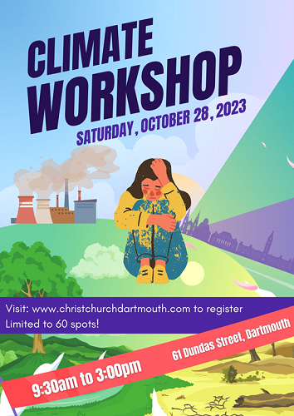

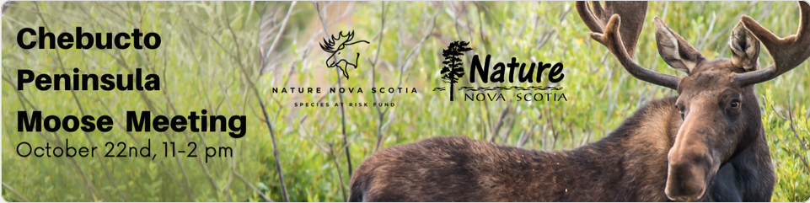

Join Nature Nova Scotia for an educational community event, the Chebucto Peninsula Moose Meeting. Nestled in the picturesque French Village, NS, this event is a celebration of nature and a platform to raise awareness about the vital importance of moose conservation. For more information and to register:
https://docs.google.com/forms/d/e/1FAIpQLSemTGBq0aIINZVPiLAUqyqI8J9N3bNfuE6VuPJNadaedsBh0A/viewform

Housing Outside the Box Solutions:

November 4 @ 9:00 am - 5:00 pm
Auxiliary Housing, Backyard Suites, & Co-Living for Community Health
Exciting things are happening in St. Margarets Bay this fall! Transition Bay St Margarets is hosting a one-day housing symposium on November 4th, building on our successful 2018 Housing Outside the Box event.
For more info: https://www.transitionbay.ca/event/housing-outside-the-box-solutions/

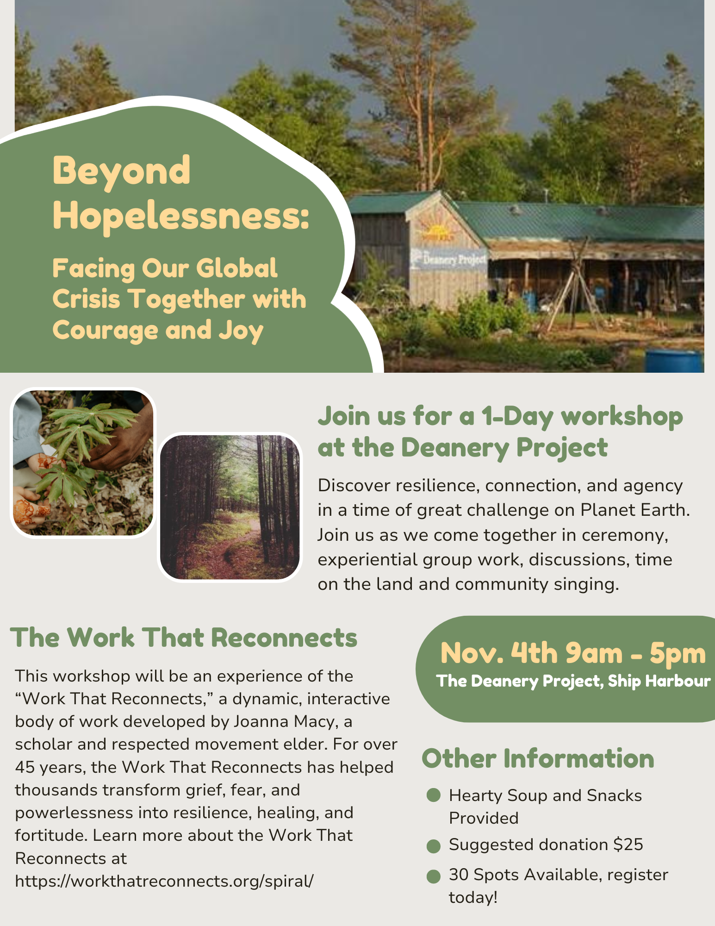
Register here: https://BeyondHopelessness.eventbrite.com
With thanks to our Advocacy Editors Eva Evans and Jesse Hamilton
Declaration - Amazonia 80x2025
Our actions in the next few years will determine the fate of our planet over the next millennia. Adding your name and sharing this declaration is a way to take action towards protecting our world’s lungs; the Amazon rainforest. This area is home to one-third of the Earth’s terrestrial plant and animal species, 20% of its flowing freshwater, and 511 Indigenous nations, including 66 uncontacted groups living in voluntary isolation. Our world can recognize how priceless this region is and we can forge a new path that works with Amazon governments and is backed by Indigenous Peoples and a global community. Join in with others from around the world in calling for a comprehensive global agreement that will ensure the permanent protection of 80% of Amazonia by 2025!

act-int.greenpeace.org/end-fossil-fuels
It's time to hold the fossil fuel industry accountable for the loss and damage they have caused to humans and biodiversity. We can’t ignore the horrific impacts to communities and especially in the global south. Polluters need to pay their fair share for the historic damage and future climate disasters. Fossil fuel greed should not be prioritised over the protection of people and the planet. This petition is demanding that governments, legislators, and courts hold the fossil fuel industry accountable for this criminal devastation. It also calls on global leaders to stop all new fossil fuel developments and commit to a rapid and fair phase out of fossil fuels.
Petition Save the Manatees! Remove the Lock. (ipetitions.com)
Did you know that manatees are related to elephants? Manatees are large aquatic mammals sometimes referred to as “sea cows”. They average 10 feet long and 1,200 pounds! They also play an important role in maintaining a healthy ecosystem. The US Fish and Wildlife Service downgraded their endangered status in 2017, but a recent petition is helping to change this. It was recently announced that this status may be restored, but it also comes after the death of hundreds of manatees in Florida over the last few years. The main cause is human related issues, such as habitat destruction and collision with boats, with locks being the second leading cause of manatee deaths in Florida. This petition is a way to help the manatees here by removing the Chiquita Lock. As the decision to change the status of manatees to endangered continues, it’s also a way to show that people care about these unique creatures and the need to protect our natural world.
Environmental Defence Petition for Capping and Lowering Emissions from Oil and Gas
The Government of Canada promised to cap and cut greenhouse gas emissions from the oil and gas industry – the largest source of emissions in the country. Right now the government is dragging its feet on releasing the new rules, and there’s a real risk that the rules won’t be strong enough. The reason? Constant lobbying from oil and gas executives. Canada cannot meet its climate commitments without cutting oil and gas pollution. We cannot afford more delays or weak rules that let oil and gas companies off the hook. Sign this petition to tell the federal government to put people in Canada ahead of the profits of oil and gas companies.

Petition to Proctor and Gamble
The rainforests in Indonesia are on fire – and companies like Procter & Gamble are complicit in this planet-wrecking arson. But now we have the chance to make change happen! There are still hundreds of reckless palm oil producers greedy enough to burn, bulldoze, and steal rainforest land from indigenous farmers. Leading consumer goods company P&G is still buying this dirty palm oil to make Head & Shoulders shampoo or Crest toothpaste – despite all the fancy promises and policies. P&G goes as far as ignoring its shareholders, consumers, and even the founders’ descendants’ calls to stop wreaking havoc on Earth.

Gender Gaps

As you may guess, I am in my next UN course. Hold on to your hats; it is called Gender and the Environment. This is my plug for the United Nations Environment Courses located at https://unccelearn.org/
There is so much to learn in this subject but I enjoyed the preambles that get you thinking. It started with a lesson on how countries have worked to try to create “equal pay for equal work’.
A story was told of how a young man and a woman with equal education and working the same job were making close to equal pay. (Close, as there always is a bit of discrimination that women are inferior and get paid less)
When the couple has a child Mom stays home. Meanwhile, Dad keeps working and takes the time to fly anywhere for meetings and in time his income increases. The stay-at-home Mom, when she does come back to work, must play catch up on the time she missed to get her pay bracket raised.
In Iceland they gave Mom and Dad equal maternity leave BUT, if you don’t use it, you lose it. It couldn’t be transferred to “the woman”. Each parent had the same time off work, paid leave. Suddenly, fathers took time off to stay home with the new baby. Not only did it help equalize the pay rate but Dads learned staying home with a newborn is WORK.
Love it!
Remember Rwanda, that African country that had a genocide in 1994. When the dust cleared, 60% of the remaining citizens were women. The country’s laws changed from women not being allowed to open a bank account without their husband’s permission to women holding positions in government. Government policies changed. Women were welcome everywhere including police and the military.
So, when climate change takes away jobs, who suffers in poorer countries? I have lots to learn.

Storm Prep
I heard from someone recently that when a storm is coming, they cook a pack of popcorn. When cool it goes into a zip lock bag to snack on any time during the storm. Low-calorie but comfort food when needed.

Christmas Prep Not a big job this week but it is time to look at the spice cabinet. Do you have enough summer savoury for the dressing? Are there plenty of spices for the baking? Just look and add what you will need to your grocery list.

Jumping Jacks
I apologize that my week has been filled with making things for the craft show (published a little Journal since I have this binding machine). What I wanted to make was a Jumping Jack toy.
You will need a box board or Bristle Board, scissors, 4 to 8 brads or paper holders, string and maybe a marker. Cut out your shapes and make holes for the brads. Put a piece of string in the back between the arms and another between the leg brads. Add a string in the middle backs that runs through the arm and leg brads and down below the feet.
Add a piece of string to the top to hold the Jack. Pull the string connecting the arms and legs and the Jack will appear as if he is doing jumping jacks.
If you are getting as busy as Grandma, print off some sheets and get the kids to work on these while you are finishing something else.
Reference Material
The best template https://fairyland.org/assets/9bed589990/Jumping-Jack-Shadow-Puppets.pdf
https://www.vam.ac.uk/__data/assets/file/0008/246923/ks2-make-a-jumping-jack.pdf
https://www.tameside.gov.uk/TamesideMBC/media/culture/Living-in-the-Past-Toys-Jumping-Jack.pdf
https://www.mgulin.com/wordpress/2013/11/spiderman-jumping-jack/
https://www.google.com/search?q=Jumping+Jack+toy+tutorial&oq=Jumping+Jack+toy+tutorial&gs_lcrp=EgZjaHJvbWUyBggAEEUYOTIHCAEQIRigATIKCAIQIRgWGB0YHtIBCjE1MDkwajBqMTWoAgCwAgA&sourceid=chrome&ie=UTF-8#fpstate=ive&vld=cid:f381f707,vid:XzRxqjvx36s,st:0

Food
You will be invited to some event where you need to bring some food dish. You will be too busy to whip up a casserole. Try making pinwheels. They all start with wraps, which again come in various sizes and flavours. I like to open the pack and put a piece of waxed paper between the wraps when I plan to use them over a long period. They don’t stick together. Not needed if bought one week to use the next. Next, we need fillings
(1) Cream cheese, dry ranch mix, finely chopped tomatoes and crumbled bacon or bacon bits moistened with a dollop of mayonnaise.
(2) Havarti, corn beef and sauerkraut
(3) Cream cheese, finely chopped cooked chicken, bacon bits, cheddar cheese and ranch dressing
(4) Cream Cheese and bits of candied cherries
(5) Finely chopped chicken, Ceasar dressing, Parmesan Cheese, mayo, and lettuce leaves
(6) Hawaiian wraps – Cream Cheese, Pineapple, Ham, and mayo
(7) Hummus and peppers
(8) Cream Cheese, cranberries, and feta
(9) Cream cheese with red and green peppers for Christmas
(10) Salami and pepperoni slices with cheese and lettuce

Have a great week everyone. Grandma is sending hugs

Peace in the Middle East
God of mercy and compassion,
of grace and reconciliation,
pour your power upon all your children in the Middle East:
Jews, Muslims and Christians,
Palestinians and Israelis.
Let hatred be turned into love, fear to trust, despair to hope,
oppression to freedom, occupation to liberation,
that violent encounters may be replaced by loving embraces,
and peace and justice could be experienced by all.
- Reverend Said
https://www.xavier.edu/jesuitresource/online-resources/prayer-index/prayers-in-times-of-crisis/prayes-for-peace-in-the-middle-east

.

.

