September 12. 2023
Facebook: https://www.facebook.com/groups/101542159983749
Did you know you can follow us on Facebook without having a Facebook account?
Website: https://www.nspeidiocese.ca/ministries/diocesan-environment-network

Email: endionspei@gmail.com

Pray with us every Monday Evening at 7 pm. Email us for the zoom link.

“To strive to safeguard the integrity of creation and sustain and renew the life of the earth”.
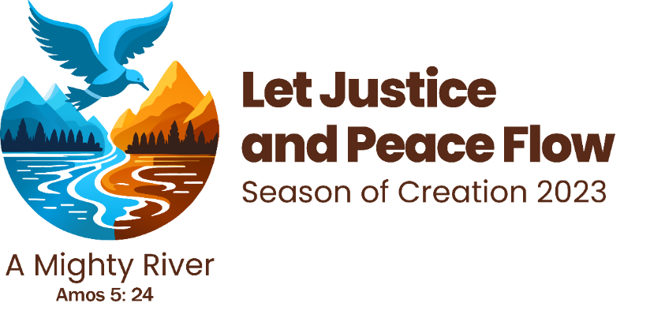
See how others are celebrating the Season of Creation
https://www.mail.laudatosimovement.org/view.html?x=a62e&m=Yo&mc=s&s=Iub&u=z&z=BZYNjwU&
Grandma’s Going Green has issued a challenge to encourage learning more about Climate Change and getting members from your parishes involved. Great thing to think about during this season. Please read her article below for more info.
Resources: https://seasonofcreation.org/2023/03/03/we-are-launching-season-of-creation-2023-let-justice-and-peace-flow/
Anglican Communion: https://acen.anglicancommunion.org/
Episcopal Guide: https://acen.anglicancommunion.org/media/503311/ACEN_Season-Of-Creation-Episcopal-Liturgical-Guide-2023.pdf
Sunday School Guide: https://acen.anglicancommunion.org/media/503332/ACEN_Season-of-Creation_Sunday-School_Christian-Aid.pdf
Global Youth Climate Strike - Sept. 15 at 12:30 p.m.

Anglicans and everyone connected to the Diocesan Environment Network are encouraged to attend. Look for the Diocesan Environment Network banner at the St Paul’s end of Grand Parade.

“Never doubt that a small group of thoughtful, committed citizens can change the world; indeed, it's the only thing that ever has.” Margaret Mead

Join us for KAIROS Climate Action Week September 11-17
For more info:
https://secure.kairoscanada.org/index.php?q=civicrm/mailing/view&reset=1&id=1593
also:
https://secure.kairoscanada.org/index.php?q=civicrm/mailing/view&reset=1&id=1599

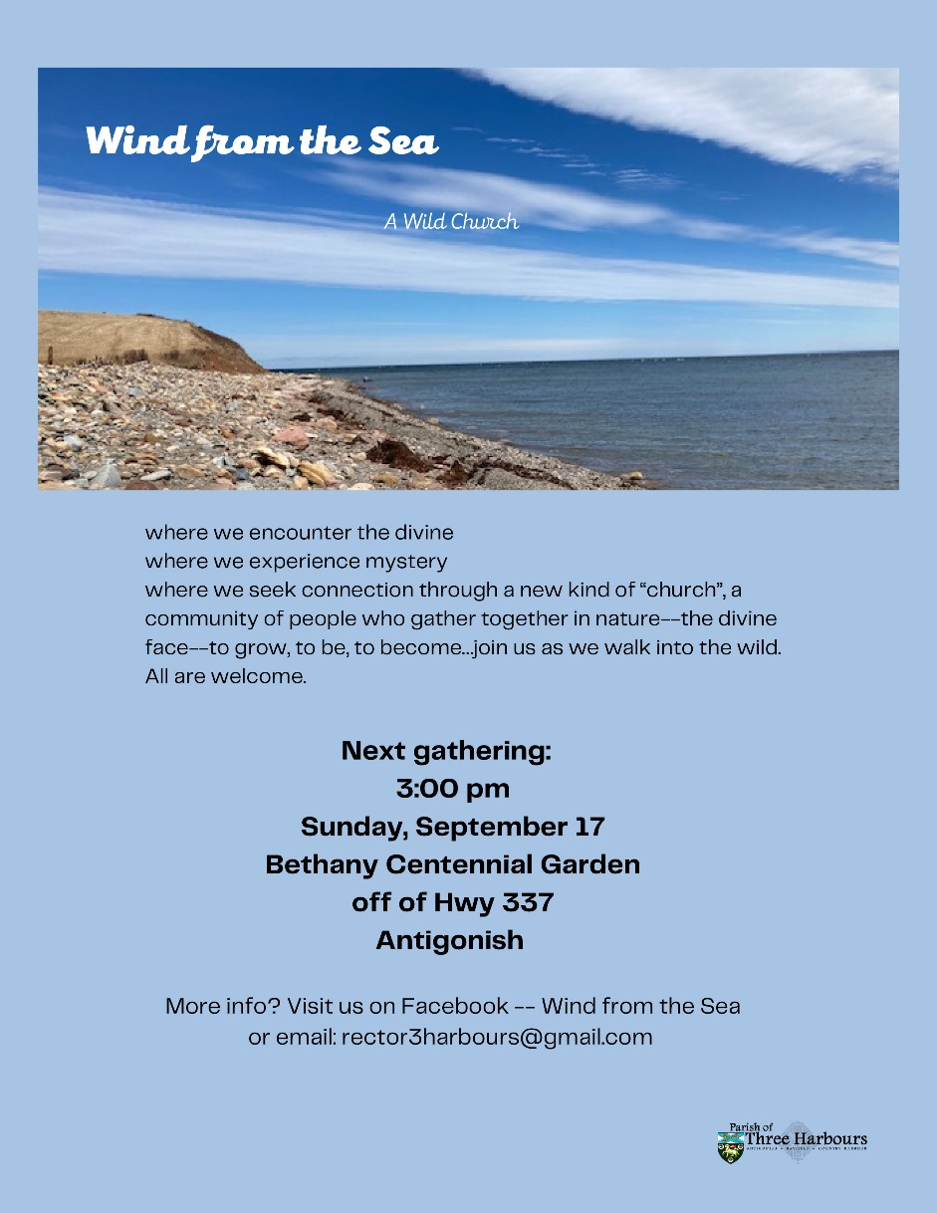
Wild Church scheduled for Sunday Sept 17th unless Hurricane Lee has other plans. Check for updates on their Facebook Page.

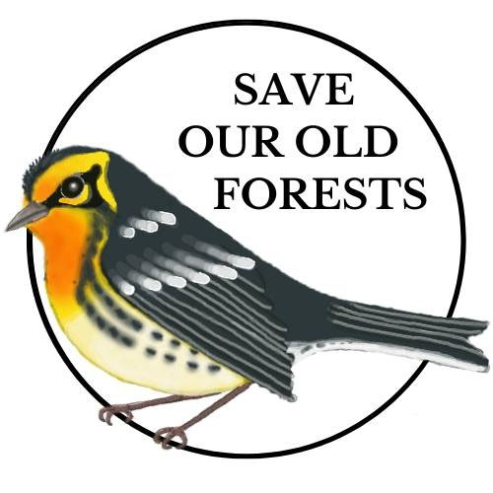
Save Our Old Forests - Petitions are due September 15. So much information on their website:
https://www.arlingtonforestprotection.ca/soof

Engaging on the Clean Electricity Regulation
Join co-hosts Ecology Action Centre and the Conservation Council of New Brunswick on Thursday Sept 21st at Noon (ADT) to chat about the Clean Electricity Regulation, learn about specifics on how it will apply in Atlantic Canada and how to participate in the consultation process. We were happy to see this first draft come through which will help Canada in achieving its goal to reach net-zero emissions on the electricity grid by 2035, but there are still loopholes which will allow fossil fuels on the grid past 2035. This webinar will provide some guidance for preparing a submission on the Clean Electricity Regulation, as the federal government needs to hear from organisations and citizens that they want these loopholes closed!

Link to webinar webform: https://ecologyaction.ca/webinar-engaging-clean-electricity-regulations

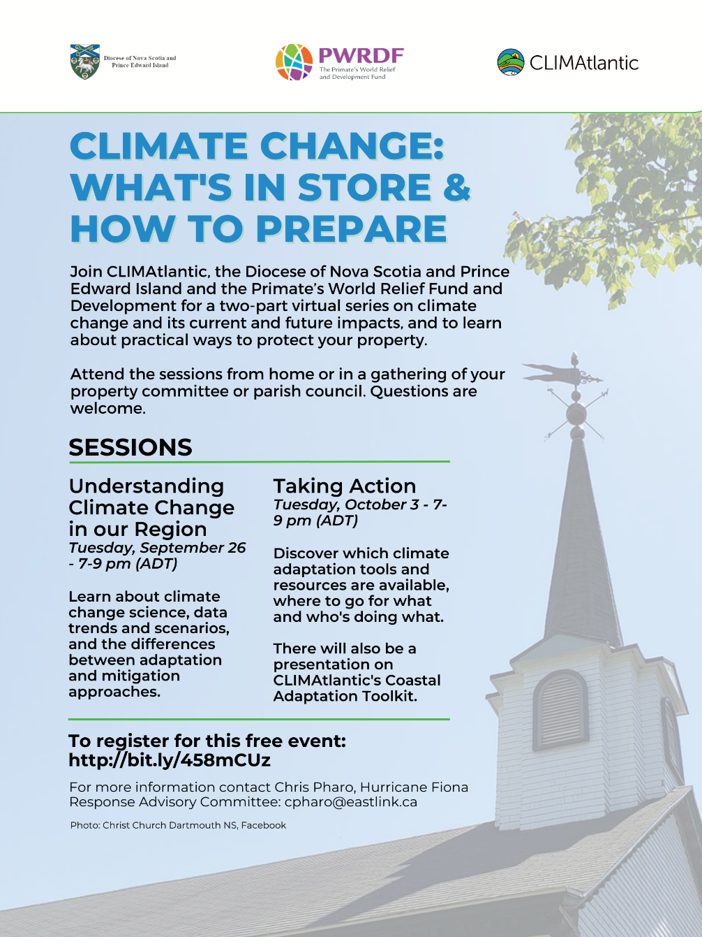
Thanks to Claudia Zinck for her garden update!

For the past five years Grandma has planted Armenian Cucumbers. They are supposed to grow a yard long (91 cm). Some years the cucumbers started and then died off but this year they are growing. This one was 22 inches (56 cm) when I noticed it start to turn yellow. It went in the pot for my mustard pickles.

Share one of your pictures, a photo, poem, songs... anything of your own that gives us hope, inspires us or reminds us of the threat to creation as a wonderful way to celebrate the Season of Creation.
You might want to tag someone else so they too can post and make our love of nature contagious.
Thanks for all the great posts so far. Keep them coming.

With thanks to our Advocacy Editors Eva Evans and Jesse Hamilton
Minister Guilbeault: Expand the Ban on Single-Use Plastics (greenpeace.ca)
To tackle the plastic pollution crisis, we need urgent action towards an ambitious plastic ban. Canada committed to achieving zero plastic waste by 2030 and ending plastic pollution, but our current plastic ban only covers about 3% of the plastic waste generated nationwide. We can clearly do better, and we can by expanding the ban to include other common single-use plastic items such as bottles, caps, bags, produce stickers, film, and wrappers. The only way to stop making so much waste and pollution is to stop making so much plastic. Send a message to our Environment and Climate Change Minister and Health Minister, urging them to act now to expand the ban on single-use plastics!
Indonesia: NO to the wholesale deforestation of the Mentawai islands! - Rainforest Rescue (rainforest-rescue.org)
Imagine white sand beaches, turquoise water, coconut trees, and lush forests. This is Sipora island in the West Sumatra Province of Indonesia and home for the Mentawai Indigenous people. In July 2023, the Mentawai people learned that a large-scale logging permit had been granted to a company to clear 20,706 hectares of their forest. This is their land, gardens, and source of food and water that could all disappear without their consent – simply so that a company can sell timber. One expert explained that deforestation on a third of the surface of such a small island would be a disaster in terms of climate mitigation, loss of biodiversity, and loss of the livelihood and way of life for the local people who depend on the forests. This petition is a way to speak out for the Mentawai people and for Sipora island, by urging the government of Indonesia to cancel this disastrous permit.

Environmental Defence Canada
Last November, Ontario’s Premier Ford removed 7,400 acres of land from the Greenbelt. Since then, reports show that 92% of the land removed was done so at the request of developers who had direct access to a Chief of Staff and who stand to gain $8.3 Billion in additional property value as a result. This clear, unethical behaviour is sadly one point on a long list of dubious policy decisions. Bill 23, with its associated policy changes, will create a process for selling off conservation lands without oversight. This will strip conservation authority that protects woodlands, wetlands and wildlife habitat. Requirements to build housing within existing cities before sprawling onto forests and farmland are also being removed. Using space, labour, and materials more wisely to build affordable housing close to transit and existing neighbourhoods are solutions to the housing crisis. Building million-dollar mansions on wetlands and farmland is not. Join in on telling Ford and your MP to reverse the Greenbelt removals and rollback other pro-sprawl policies.

Save Northern Rockies Wolves (biologicaldiversity.org)
Wolves are intelligent, social animals, who are crucial to helping their ecosystems thrive. Despite this, they are being massacred in places like Idaho, Montana, and Wyoming. Hundreds are killed every year and barbaric hunting methods continue to be a reality for these majestic creatures. Entrusting wolf management to states has resulted in a bloody war on wolves. The hope is that the Biden administration can restore the Endangered Species Act to include protection for gray wolves in the northern Rocky Mountains. Add your name to help push for this protection to be restored for wolves immediately.

Environment Badges
For years Grandma has been looking for a youth or community wide, program or club, that would promote the environment. There are quite a few out there but nothing that seemed quite “right” for me (us).
I think I have found it.
The Food and Agriculture Organization of the United Nations, under YUNGA, Youth and United Nations Global Alliance has a program of Challenge Badges. There are 15 Badges to earn for completing a variety of challenges. ONE OF THEM is on Climate Change.
The age groups are broken down into 5-10, 10-15 and OVER 15 without a ceiling on the age. So, Grandma could do the challenge. I could do the challenge with my grandbabies, each working according to their age group. This challenge could be completed remotely like distance education. This is an all-inclusive, intergenerational, type of environment activity that has the authority of the United Nations.
These badges involve a lot of work. I believe we could only take on ONE Badge a year. Other Badges like Food Security, Disaster Risk, Plastic Tide Turner, or Energy are equally important. Once we get a foothold with one Badge we can turn to the next. Perhaps offering a CHOICE of Badges in time
I am thinking of a remote club. We would need to learn Teams or Zoom but a group email could work for a weekly check in. I know I tend to get a bit ambitious with the environment. I am only asking for opinions.
https://www.wagggs.org/en/resources/yunga-challenge-badges/
or
The web page is https://www.fao.org/yunga/resources/challenge-badges/climate-change/en/
I am NOT asking for volunteers.
All I want right now is if you might know of one or two people in your parish that this might interest. We can do it as individuals, but a group is more fun.
Once I have studied it enough to see if this might be wanted, then I will bug Rev. Marion and Bishop Sandra. Let’s show the world that tiny parishes in Eastern Canada can step up for the environment.
My email is claudiaazinck@gmail.com
Oddities
I love seeing different things that are out there in the world. This week I found “floating bridges” Picture floating docks joined together. This one is in China. It is used by pedestrians and cars although cars need to go slow to prevent waves from causing problems for the riverbanks.

https://www.facebook.com/hashtag/floatingwoodenbridge
Even Dubai has a floating bridge.
http://tourmet.com/floating-bridge-dubai/
Also, in Seatle, Washington
https://www.enr.com/blogs/15-evergreen/post/41915-worlds-longest-floating-bridge-earns-award-on-first-birthday
Craft
Maybe this falls under activity more than craft.
Straw Rockets
You will need a milkshake straw (or often the reusable straws are big enough.)
A strip of paper about 2 x 8 inches.
Decorating pens, markers, stickers, etc.
Sticky tape (Scotch tape or any other brand)
Decorate your strip of paper. Wrap it around the straw and tape the long side. Pulling back the straw a bit, fold over the top end and tape it. Blow through your straw and watch your rocket fly.
So simple. Hours of fun.

Something to Eat
The zucchini continues to grow. First came the stir-fries. Then came the minced zucchini put away in the freezer for winter. Then came the basket of zucchini going to service and coming home empty. Not wanting to add a great amount to the freezer I grabbed my recipe box and found a great cake for a 10 x 13 pan.
Lemon Blueberry Zucchini Cake
In one bowl.
2 cups shredded zucchini.
1 cup butter, margarine or shortening.
1 cup and a bit of sugar
2-3 tablespoons of lemon juice
2 eggs
In a second bowl combine
3 cups and a bit of flour
1 tsp. baking soda
1 tsp baking powder
A shake of salt
2 cups fresh blueberries
Add the wet ingredients to the dry bowl adding in ½ cup of milk.
Put in a 10 x 13 or 10 x 15 pan. Bake at 350 for 30 minutes.
I use a lemon icing on this cake. Yeah, I love retirement.
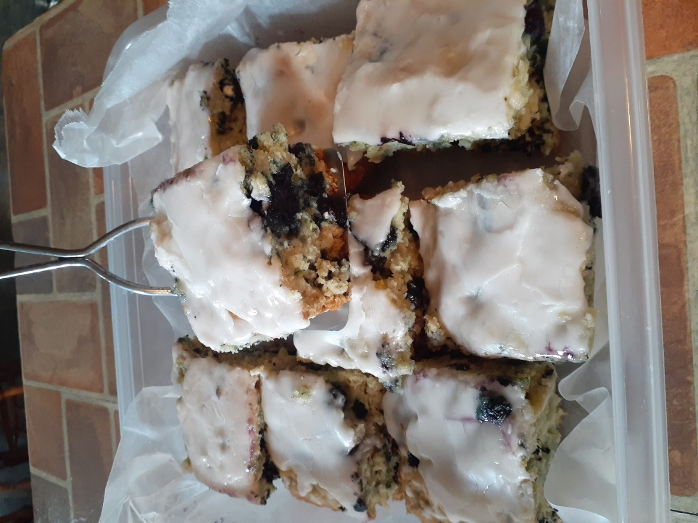

FROM EVERY FAMILY, TRIBE AND NATION
O God of unchangeable love, you see the beauty and worth of all you have created. Through Jesus you come down to us, to turn our hearts to you, to one another and to all your creation. Heal us, that we may care for your world and see every family, tribe, language and people as an interconnected expression of your grace and glory; through Jesus Christ who lives and creates with you the Holy Spirit, one God now and forever.
– Christ Church Cathedral, Indianapolis, IN
https://www.episcopalrelief.org/let-us-pray/season-of-creation-prayers/

.

