September 19. 2023
Facebook: https://www.facebook.com/groups/101542159983749
Website: https://www.nspeidiocese.ca/ministries/diocesan-environment-network

Email: endionspei@gmail.com
Pray with us every Monday Evening at 7 pm. Email us for the zoom link.
“To strive to safeguard the integrity of creation and sustain and renew the life of the earth”.
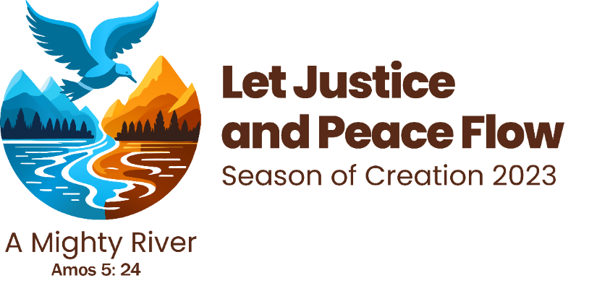
Anglican Communion: https://acen.anglicancommunion.org/
Episcopal Guide: https://acen.anglicancommunion.org/media/503311/ACEN_Season-Of-Creation-Episcopal-Liturgical-Guide-2023.pdf
Sunday School Guide: https://acen.anglicancommunion.org/media/503332/ACEN_Season-of-Creation_Sunday-School_Christian-Aid.pdf

How are you celebrating?
We would love to share your ideas with others.
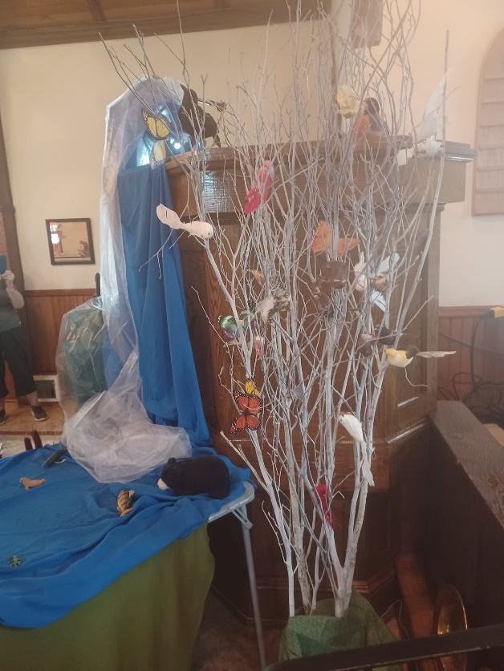  Thanks to Rev. Michelle Schofield Bull for sharing on DEN’s Facebook page their decorations at Emmanuel Anglican Church in Spryfield. | 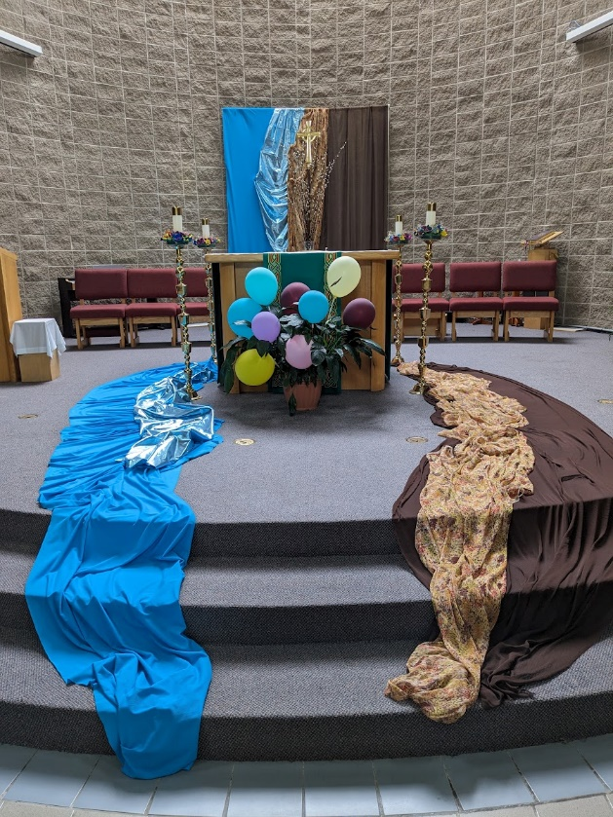  Sometimes Sept. 1 is not the best time to begin the Season of Creation in our parishes. The Church of St. Andrew in Cole Harbour began on the 17th and they are building the logo week by week. This past Sunday they began with the river.

Kudos to the organizers and all who participated. It was well run and the speeches were inspirational. Please scroll down on our Facebook page for photos. https://www.facebook.com/groups/101542159983749
Grateful thanks to Bishop Sandra for joining us and helping to carry the DEN banner.
“Never doubt that a small group of thoughtful, committed citizens can change the world; indeed, it's the only thing that ever has.” Margaret Mead

The Rev. Charles Bull is offering an opportunity to avail yourselves of this Special Presentation:
KEEPING FAITH IN A TIME OF CLIMATE CHANGE.
The Rev. Canon Charles Bull gave this message for the first time at Bedford United Church on September 3, and it was very well received. He is now offering to come and speak at any church either in a two-hour interactive seminar at a time to be arranged OR as a 30-minute sermon at a special service on a Sunday morning. Here is a link to the Sept. 3 sermon and some listener reviews.
https://youtu.be/MBB6rS9GhFg?si=myOuzDUvdRG8GTHV
Charles was an excellent speaker and created a beautiful sense of faith in the midst of our climate demise. I really appreciated how he named our various emotions and responses to the climate crisis.
Amazing service! Charles' powerful and 'real' talk is a fabulous, accurate account of the precious time in which we live on this precious planet. WATCH THIS ONE!!!!
I was riveted by this. Really the best thing I have heard on climate change, period.

Very helpful to all who hear. Thanks for putting into words the intuitions that so many people feel. You have great delivery. It has an effect. Keep giving this sermon!

The Anglican Church has church parking lots throughout the province. The Diocesan Environment Network (DEN) has been engaged in research on the possibility of installing EV charging stations in our church parking lots. We have also offered our church parking lots to municipalities throughout the province as locations for the installation of the charging stations. Any information that people connected to DEN have to offer would be appreciated. We can be contacted at endionspei@gmail.com
Thank you,
Rev Marian

So much information on this website including webinars, employment opportunities, online education and so much more. You can also subscribe to their newsletter.
https://netzeroatlantic.ca/

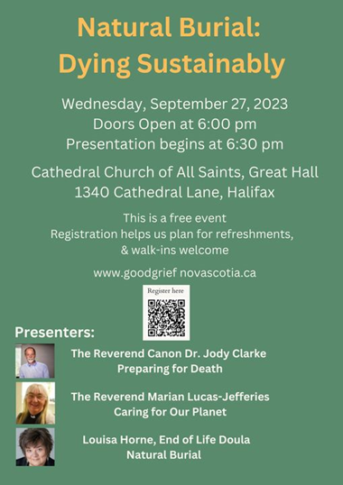
This session is a part of a week of events from September 23 to 30 designed to support grievers in our communities and to grow grief literacy across Nova Scotia and beyond. To learn more about this initiative visit Good Grief, Nova Scotia.

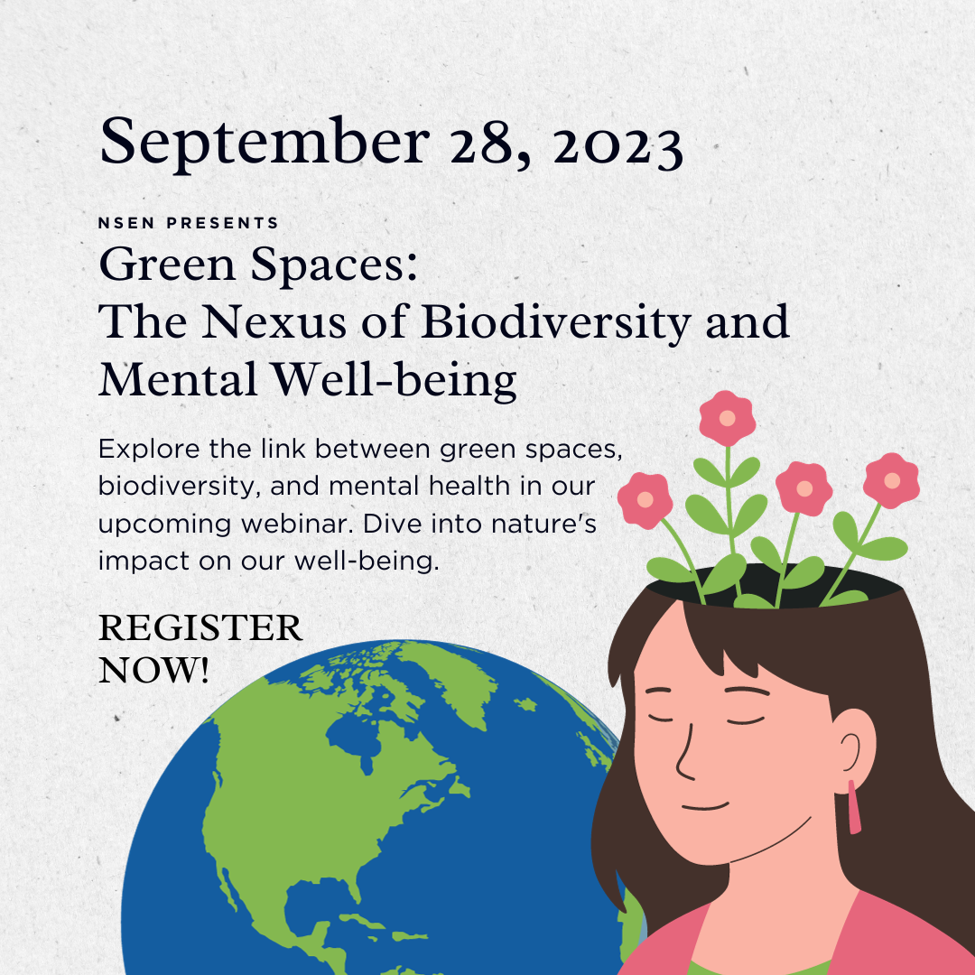
Register here:
https://nsenvironmentalnetwork.app.neoncrm.com/np/clients/nsenvironmentalnetwork/event.jsp?event=104&secureIdCustomer=1&

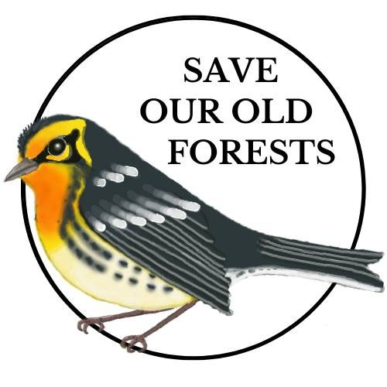
Lots of great learning opportunities coming up from Save our Old Forests including a Mycology Workshop, iNaturalist in the Forest and a presentation by the Blomidon Naturalists Society. Find out more here:
https://www.arlingtonforestprotection.ca/upcoming-events

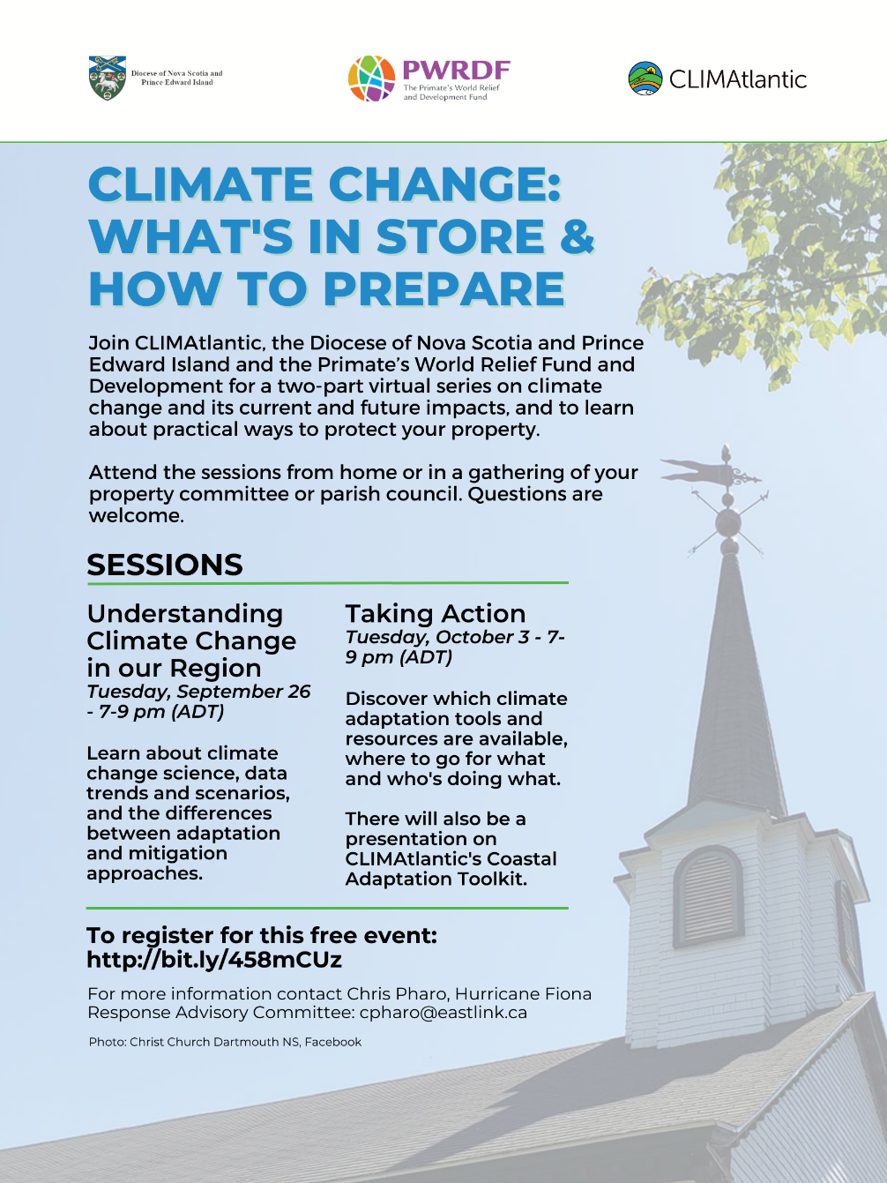
Sent to us from Grandma:  The package of seeds said “sunflowers” about 5 years ago as I planted these on the side of the house. I feel they are more of a Jerusalem Artichoke flower. Either way they are a perennial that comes back every year. There is not a petal left after the hurricane, but they sure were pretty, all summer long. | Since the deer ate all the beans at the Church of Saint Andrew’s garden, this is their first harvest. Sadly, these were pushing up against the sides of the raised beds which restricted their growth and made them really tough to pluck off the plants.  Odd shape and all, these will be dropped off at Margaret’s House.

Share one of your pictures, a photo, poem, songs... anything of your own that gives us hope, inspires us or reminds us of the threat to creation as a wonderful way to celebrate the Season of Creation.
You might want to tag someone else so they too can post and make our love of nature contagious.
Thanks for all the great posts so far. Keep them coming.

With thanks to our Advocacy Editors Eva Evans and Jesse Hamilton
Say NO to giant cruise ships (eko.org)
Amidst the climate crisis, Royal Caribbean has chosen to announce the launch of the largest cruise ship in the world. For the environment, this means an increase in ocean waste, higher levels of greenhouse gasses, and a greater risk for animal and plant species. Weighing five times more than the Titanic, this single cruise ship will cause as much pollution as that of millions of cars! Cruise ships are known to release their wastewater into the ocean with minimal treatment, with other waste including plastic also often ending up in our waters. Their engines run on liquefied gas extracted by fracking and when they have to be dismantled, this typically happens on beaches in low-income countries. They are a perfect allegory for the way society seems ready to sacrifice our environment in the name of profit. The launch of this ship happens in January 2024, but massive mobilization has helped ban cruise ships in ports such as Venice and Amsterdam. This petition is a chance to make a powerful statement to place cruise regulations at the heart of the discussion and future of this industry.
Stop Bill 23: Protect the Greenbelt and Build Real Affordable Housing | Leadnow.ca
Destroying the Greenbelt means destroying wetlands, farmland, and woodlands. It also undermines important and needed environmental protections. Bill 23 is an attack on the environment and on democracy, all under the guise of expanding housing. It allows Ford to take 7,400 acres of farmland and natural areas, and then strip them of the protections that keep our drinking water safe, guard wetlands, protect wildlife, and ensure flood protection. In the quest to pave over the Greenbelt, Ford undermines the planning power of municipalities, forgoes requirements for public meetings, and overrides the community’s ability to appeal decisions. Your voice is needed to show public support in demanding Bill 23 be stopped and the Greenbelt remain green.
Avaaz - Stop this Total madness
Oil giant TotalEnergies is about to build the biggest heated oil pipeline in the world, right through some of the world's most important elephant, lion, and chimpanzee reserves in Uganda and Tanzania. It will displace tens of thousands of families and tip the planet closer towards climate catastrophe. Local communities are doing everything they can to fight the project, but they’re up against one of the most powerful companies on earth. Police recently arrested four more student climate activists who were protesting the construction of the pipeline. Fossil fuel projects are being forced on people while the civic space continues to shrink for climate activists. This petition can be a way to show global support while putting pressure on the CEO of TotalEnergies and the backers of EACOP.
Sign the petition to save British Columbia’s old-growth forests - Greenpeace Canada
One of Canada’s natural treasures is at risk of disappearing if we don’t take action now. British Columbia’s old-growth forests are being chopped down at alarming rates and have been nearly eliminated by industrial activity. B.C. holds an incredible amount of biodiversity, with about half of all species in Canada found here. More than 2,000 species of these animals and plants are now at risk of disappearing. Protecting old forests is an important and available tool in the fight against climate change. In fact, without B.C.’s last stands of old growth trees, Canada may not be able to meet its carbon-reduction goals under the Paris Agreement. We need the Premier to keep his promises and for our country to step up to protect these precious old-growth forests.
Petition to World Leaders re Loss & Damage Fund
The world’s 20 wealthiest nations are responsible for nearly 80% of total greenhouse gas emissions, while all small island nations combined account for barely 1%. But while developing nations contribute very little to climate change, they often bear the greatest burden. The climate crisis costs communities billions of dollars in damages and claims precious lives. While catastrophic storms make headlines, warming temperatures, rising sea levels, and biodiversity loss receive less attention but have an increasingly urgent and costly toll for developing nations. These countries need global support for climate-related loss and damage.

Hurricanes – Got to love them.
What do you do when your electricity goes off early Saturday morning as you try to race the storm to get your article in.
You breathe and think, “I’ll pick that up and get it off when the power comes back.” After all it had its spell check and grammar check. It will just take a minute.
The power came back.
Not only was my article no where to found but neither was Microsoft Word.
“Re-install Word” they said, “and it will pop up.” It didn’t.
“Restart the computer and it will be there.” It wasn’t.
Of course, in my mind it was a fantastic article on erosion. We will see about that when I rewrite it.
We got through the hurricane with little damage. Trees were stripped of their leaves. One branch fell out front and apparently someone stopped and piled pieces on the side of the road. Bless them.
We did all the usual things. Made sure we had plenty of water, had a little cash, replaced batteries and had extra in the house, filled the car with gas, charged phones and lamps, plenty of gas for the generator and medications checked for when needed. The lawn furniture and ornaments were put away. I cooked extra chicken and pizza. We were ready!
One friend gave me a new tip. When he hears a hurricane is coming, he fills empty milk cartons and freezes them. When he expects the power to go out, he puts these in a cooler with milk, butter and things you often go into your fridge for. He adds a couple frozen water milk cartons in the fridge that helps the rest of the food. Then till power comes back he leaves his fridge closed.
My son-in-law installed this convertor kit for the generator, where I can hook up and start the generator outside. The cord from the generator connects to 6 outlets indoors. It wasn’t overly expensive, under $250. If we want, we can hook up our router and tv to the outlet and sit and watch shows during a storm. We prefer an early night of sleep, but the grandbabies see a storm as a movie night.
Do you have any tips for storm days? claudiaazinck@gmail.com
Cardboard Looms - Weaving a Potholder
A cereal box or piece of heavier cardboard makes a good loom to make a pot holder or cloth trivet for under a hot pot.
Cut your cardboard a bit bigger than what you want for a finished project. Cut half inch deep slits into the cardboard equal distance apart on the short ends.
Using yarn or t-shirt material, start at the outer most slit in the cardboard and wrap the yarn around and around the long side of the cardboard loom.
Using either yarn on a darning needle or heavier material hand weave between the upright strands, weave one over and one under.
When the loom is full carefully cut the upright yarn and tie with a square knot.
If this is enjoyable, try weaving two over and two under or one under and two over making up new patterns for each hot mat.
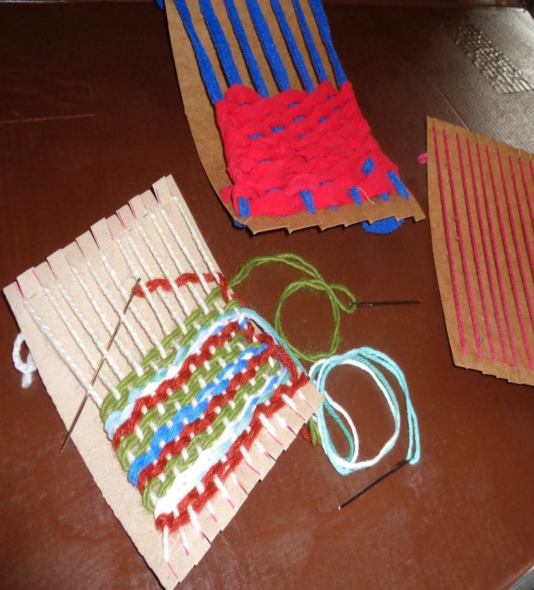

Something to Eat - Moussaka
This is a long recipe but one our family loves if we can get eggplants. Luckily my friend Bonnie had an overflow of Eggplant.
Boil 3-6 potatoes, cool and set aside.
Slice eggplants, sprinkle with salt and bake in an oven 15-20 minutes, set aside
Cook hamburger and add a tomato sauce. Set aside.
Make a Bechamel Sauce and set aside.
Bechamel Sauce
Half cup butter.
Half cup flour.
2 cups milk (or other dairy). Cook till thick
Greasing a 10 x 13-inch pan layer as follows
A layer of tomato sauce
Half of the potatoes sliced
Half the eggplant slices
Half of the Bechamel Sauce.
Repeat the layers.
Some people like a shredded white cheese on top.
Bake at 350 for 45 minutes

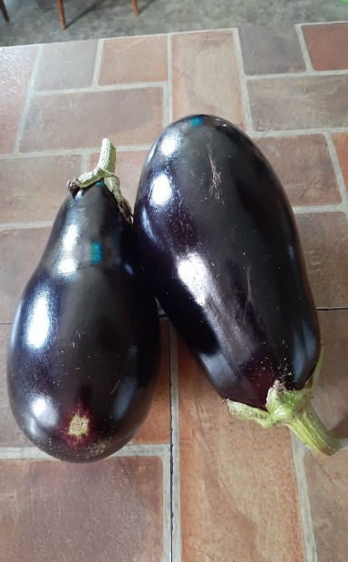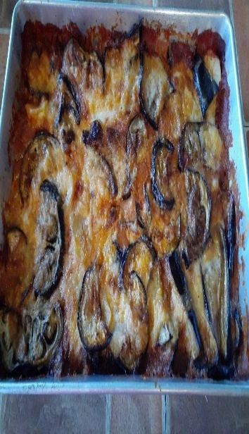
God of all Creation,
At the beginning of time
You placed a single mandate on humankind
To be stewards of Creation
To replenish and nurture all generations
What you have made
We kneel today amid that same Creation-
A world that is, in many ways, more splendid than ever
But, in too many ways, scarred beyond recognition
Turn us from our unmindfulness
Help our tough be light
Help us renew the worlds that supports us
So we may once more know Creation
As it was in the beginning
Amen
https://interfaithpowerandlight.org/faithclimateactionweek/prayers-and-climate-blessings/#:~:text=We%20hold%20brothers%20and%20sisters,actions%20to%20limit%20carbon%20emissions.

.

