

**May 23. 2023**

**Facebook:** **https://www.facebook.com/groups/101542159983749**

**Website:** **https://www.nspeidiocese.ca/ministries/diocesan-environment-network**

##### **Email:** **endionspei@gmail.com**

**Our Mission:** “To strive to safeguard the integrity of creation and sustain and renew the life of the earth”.

|  |  |
| --- | --- |
| C:\Users\cayla\AppData\Local\Temp\image.png | **Test Drive**  **An Electric Vehicle**  **at SYNOD**  **Email link below to register your spot.**  **Date: Friday, May 26**  **Time: 930 am - 1230 pm**  **Location: Outside the Student Union Building on the Dal campus**. |

**https://outlook.office365.com/owa/calendar/NextRideDalhousie@cleanfoundation.ca/bookings/?fbclid=IwAR30RlJ7F8wS3UNVu9XY67qhMW-dE1WhOD_sQznDgv2POfQaPbVJxFWP4zo**

**Come see our DEN display at Synod**

|  |  |
| --- | --- |
| C:\Users\cayla\AppData\Local\Temp\image.png | Do your hands need to keep busy while your brain is working?  DEN will have yarn available. This is a very strong yarn that makes excellent pot scrubbers or cat beds. It washes with no shrinkage. We will post a photo on the FB page.  A size 5 crochet hook is great if you want to bring your own or equivalent knitting needles.  After Synod, feel free to take home with you as much as you need. |



It looks like a dry summer ahead and water is a precious resource. There are a number of groups selling rain barrels in Atlantic Canada. To find one nearest you: https://rainbarrel.ca/

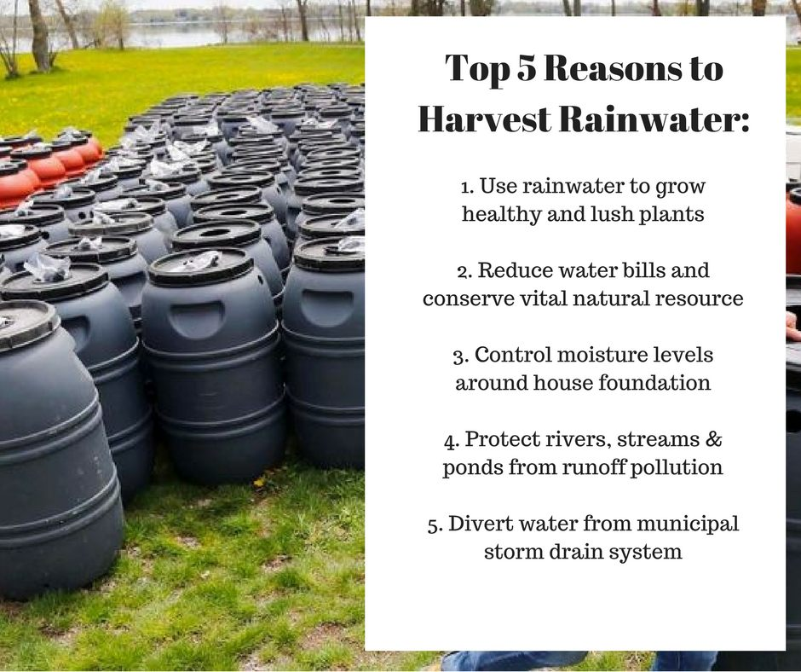



*“The Campaign to Protect Offshore Nova Scotia (CPONS), working since 2016 to protect our coastal waters, is excited to present the* ***“Celebrate World Oceans Day Expo, on Saturday, June 10th, 2023, from 12:30 to 3:30 PM at the Community Centre, 15 Green St., Lunenburg.*** *This is a family friendly afternoon. Everyone is welcome, and admission is free.*

*The Expo will fortify our community's awareness of the interdependence of not only the North Atlantic, its watersheds, and coastal communities, but also environmental, economic, and climate solutions.*

*Be part of the lively afternoon of entertainment, learning and action. For more information, follow CPONS on FaceBook for updates or call 902 527 2928.”*



**Deanery Facebook Reboot!**

**We have a fresh New Page ....Help needed!**

**Our big Facebook news is that we have had to move to a new page!** **Find it here!!**  **We would be so appreciative if you could “like”** **our new page** **and follow us there.**   
**Please share the new site with family, friends, and anyone else who may be interested in what we do at the Deanery!**

----------------------------------------------------------------------------------------------------------------------------------------------**Apply for the Global Cultural Relations Programme 2023**

Please click on the link below for more information. The deadline to apply is May 28th. We are told they always struggle to get Canadian applicants. Maybe this is you! In 2023, the GCRP will be held in **Madrid, Spain** from **10-13 October** and will be conducted in English.

https://www.cultureinexternalrelations.eu/2023/04/26/apply-for-the-global-cultural-relations-programme-2023/

--------------------------------------------------------------------------------------------------------------------------------------------------

Join the Rev. Tasha Brubaker for *Wild Church* on Sunday June 18th. Natasha tells us this will be a time of *“holy wander" and reflections, drawing on eco-mystics from all traditions, though with a special emphasis on our own Christian mystics and teachings.”*

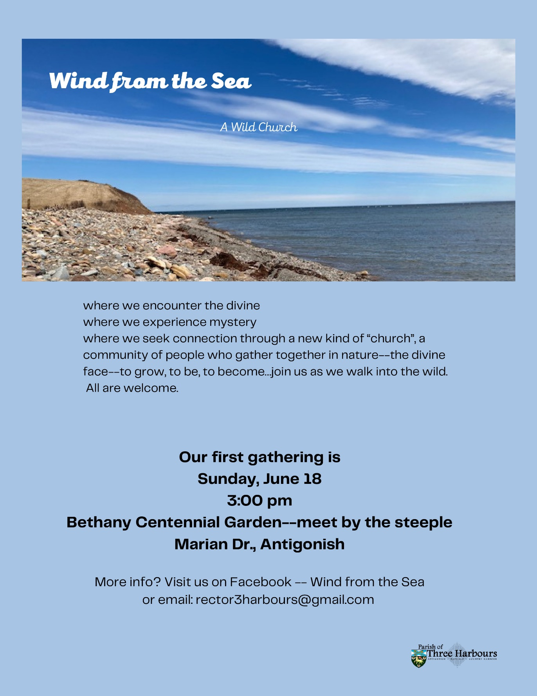



Thank you to Anne Marie Dalton for her permission to use her book review originally published in the “Good Tidings” newsletter from the Earth, Spirit, Action Team at St. Matthew’s United Church.

***Book Notes by Anne Marie Dalton on “Weather, Religion, And Climate Change” by Sigurd Bergmann, Routledge Press, 2021.***

*This is a well-researched and at times quite academic account of how weather has interacted with religious belief and practices over centuries. Bergmann moves talk about weather beyond the purview of science alone and reveals the many ways in which humans of all faiths have interacted with weather in theology, art, architecture and simple everyday decision making. ‘Does God speak through weather?’ has long been a theological conundrum. Bergmann speaks of church architecture as “built faith.” We can see in our church architecture, for example, what and how our ancestors believed and what contextual forces affected that faith, weather being one such force. Gothic architecture reflected not only theological concepts of God’s transcendence, power, and beauty, but also the increase of rainy weather as the polluting effects of the industrial revolution spread in Europe (think of the gargoyles spouting excess water and the high sloping roofs dealing with ice and snow, for example). This and other reflections lead to the questions raised in the final chapter: How are the conditions of climate change and its unequal effects across the planet and its peoples influencing our concepts of God today? How is weather an expression of God’s presence? How is it challenging our faith? And what will our “built faith” look like going forward?*



|  |  |
| --- | --- |
| Environmental Justice. Ricardo Levins Morales, scratchboard, ink, and watercolor. Photo: Heidi de Vries | Kairos Canada is asking us to urge the Senate to pass Bill-226 into law. This law will be an effective tool in the struggle against environmental racism. https://www.kairoscanada.org/urge-senators-to-redress-environmental-racism-and-support-bill-c-226 |

**Petition to Ban Harmful Insecticides and Herbicides**

|  |
| --- |
| The bees and our food system are in trouble. The American bumblebee, a native species of Canada, is on the verge of extinction. Shockingly, scientists have estimated that the population of bumblebees has declined by a staggering 99 percent over the past 30 years, with grave implications for the entire ecosystem. Bees, butterflies, and other essential pollinators are disappearing at an alarming rate worldwide. This dire situation is caused by the use of harmful insecticides, diseases, habitat loss, and climate change. Scientists estimate that 1/3 of the global food supply relies on the pollination services provided by bees and other insects.Without them, our entire food system will be in serious jeopardy. By signing this petition, you can call upon Steven Guilbeault, the Minister of Environment and Climate Change, to take immediate action and ban the dangerous insecticides which are harmful to bees and other pollinators. |

**GreenPeace Petition Against Deep Sea Mining**

|  |
| --- |
| Deep sea mining is a huge, new threat to the unique creatures that call the deep sea home. Scientists warn this mining poses severe risks and potentially irreversible damage to the deep ocean and marine life that lives there. The gigantic machines used to scoop, dredge, and cut mineral deposits from the ocean’s deep seabed could disrupt the natural processes that store carbon and adversely affect coastal communities.  The Canada –based Metals Company (TMC) is attempting to exploit the seabed and destroy pristine ecosystems along the way. Good news is that earlier this month the shipping company Maersk – one of their major investors – announced plans to divest from TMC. Global Ocean Treaty was signed just a few months ago. But now a moratorium on deep sea mining is also needed, since large areas are still left unprotected from exploitation. This petition calls on the government to stay true to its commitment and say no to deep sea mining. |

|  |
| --- |
| **Take Action, Sign a Petition | The Rainforest Site, a GreaterGood project**  The vaquita is a small porpoise found only in the Gulf of California, and it is on the brink of extinction. The Gulf of California is one of the most diverse and productive marine regions in the world, and the Vaquita play a vital role in the ecosystem here. The Mexican government has promised to take action but they have been slow to act. The vaquita cannot wait. This petition is calling on the President of Mexico and the Secretariat of Environment and Natural Resources to take immediate action to protect the vaquita from extinction.  **Mining Company Belo Sun Out of the Amazon! | Amazon Watch**  Industrial mining is a big problem in the Brazilian Amazon rainforest. It has caused a sharp increase in deforestation, and yet requests for permits to mine on Indigenous lands steadily increase. Canada’s Belo Sun Mining Corporation is planning projects here. Their projects will threaten the already fragile Xingu River Basin - one of the most biodiverse places on Earth. Sign the petition to join the campaign to stop Belo Sun from destroying the Amazon and its traditional communities!  **Stop fracking Vaca Muerta! - 350**  Vaca Muerta is a unique area in Patagonia that holds the world’s second largest shale deposit. The Mapuche People from this area have been demanding that fossil fuel extraction stop and big banks cease their financial support for fracking in Vaca Muerta. Fracking is devastating for the environment and the local people. These fracking companies are dumping toxic waste close to homes and farmland. The Mapuche are having their ancestral land stolen and decimated by wells, pipelines, heavy machinery, and poisoned water. The oil and gas locked deep underground here could release 50 billion tons of co2 into our atmosphere, pushing our earth further towards climate breakdown. This petition is going to a series of CEO’s and their banks for AGM’s this month. It says it’s not ok to fund and actively profit from fracking at the communities', nature’s, and the world’s expense. |



|  |  |  |
| --- | --- | --- |
| **REPAIR**  Learning to repair anything was just something we were taught as children. I didn’t realize that until I visited my Dartmouth family recently.  The kids were playing in the backyard and came in because one of the girls had caught her skirt and ripped the fabric. A new dress was found for her but what amazed the girls was my daughter reaching for her sewing box. They gathered around and watched while what was a small rip was sewn back together. To them, this simple act was amazing.  Is there such a thing as a shoe repair shop anymore? Besides repairs, I remember new soles being put on shoes to make them last longer. New shoelaces were a treat to put in old sneakers that seemed to last longer than they do now.  Having a squeaky clothes dryer, I am faced with the choice of getting a repair man from 60km away or learning how to put in the new pulley wheel and drum belt myself. I did look at how to do it; I just don’t want to fight with that drum. The thought of buying a new dryer never occurred to me.  Before the pandemic, I went to a workshop at a church in Tantallon. They were showing off so many ways to Do It Yourself or Repair what you have.  Maybe that is an event to put on in these large buildings with the steeples on the top. Every second pew has someone teaching something. It could be as small as how to put a patch on or sew a rip or sharpen a knife or make a planting pot or fire starters from a newspaper.  What you and I think are just everyday things that everyone knows about, isn’t. What do you repair? What task do you do? Think about passing them on.  **Garden** Now is the time to start potting all those runaway plants that love to pop up outside the gardens. It is the lilies in my yard. Luckily, I have a good amount of plant pots from years past, and this large pile of topsoil I am still using to fill garden boxes.  Usually, our parish has a plant giveaway but between my illness and losing our priest, it is just not happening this year. However, I am lucky to have a spot at the end of my driveway. It is amazing how a sign reading FREE anything will cause people to stop and pick things up.  A plant giveaway after service is an easy project. Name a date and perhaps have a rain date. People bring plants to church and leave them outside or put them on a tarp-lined front pew. After service, people take what they want. Then have someone willing to take home the leftovers as few want their extra plants back.  What is your new plant this year? I am retrying two new plants that didn’t work out before. One is the Armenian cucumbers that grow a yard long. Last year was a hard year to get ANY cucumber to grow so I am trying again.  The second plant is Pac Choy. Mine grew so good but it needs to be cut and eaten in a very small window. Mine bolted last year and we didn’t get a good feed. My bad! So, we try again.  That is the fun of gardening. If something didn’t work, then see how else that goal can be accomplished. Please send messages as the summer goes on of your gardens. Do you have a church flower garden? Do you have one bean plant by your back door? One plant can give many snacks or several dinner veggies. I would love to see pictures. You can always reach me at claudiaazinck@gmail.com  For those that are wondering how the new low greenhouses work, I purchased one on a cold snowy day a few months back. They are easy enough to put together. Mine is in a sheltered spot but we have had windy days, and nothing has moved them yet. They hold 4 seed trays. Zippered openings.   |  |  | | --- | --- | |  | Image preview |   **Something I tried** We have a generator that we keep in a shed and roll it out when needed. The only problem is that in cold weather, the battery for the remote goes silent. When the power is on, it is just a matter of hooking up the battery charger for a couple of hours. The problem is that when we need the generator, the power is usually out.  A new toy I bought myself was a solar battery charger. I decided to try it out this week and was pleasantly surprised to have the generator start with the remote after just a couple of hours of being charged. This might be a good backup for most households.  Image preview  My apologies that I do not have a craft this week. Grandma is so busy in the yard I have had little time to do crafts. No worries. Since I am retired, I am starting to go to the bookmobile next week. I will have so many books to recommend after that and probably plenty of crafts to share what I did.  **Something to Eat**  Grandma bought a 30-pack of eggs this week and was surprised to see recipes on the back of the wrapper. The brand was Nova Eggs but clearly printed was the message that the recipes were from the Canadian Egg Marketing Agency. I couldn’t find a website for them, but a treasure chest awaits the baker at eggs.ca.  Don’t ice these Lemon Coconut Squares. So easy and so good  **Lemon Coconut Squares**  **Crust**  2 cups flour  1 cup butter or margarine  ½ cup icing sugar  Mix, put in a 9 x 13 pan, and bake at 350F for 20-25 minutes let cool  **Filling**  4 eggs  2 cups sugar (can’t scrimp with this one)  ½ cup lemon juice  ¼ cup flour  ½ tsp. baking powder  1 cup coconut  Mix up the filling and pour on the cooled crust and bake for another 25 minutes, Don’t ice them. The coconut rises to the top. They are sweet enough as they are and make a large amount of 2-inch squares.    Grateful to the webpage Godspace for their permission to use this **Earth Shalom Lament** by Karen Wilk.  Earth shalom, The call of this poem, While glaciers melt And ocean reefs swelt, Chemicals cloud the atmosphere And plastics pollute, far and near God’s precious creatures going extinct And all of it, all of us, intricately linked… Yet no confession, no lament, No remorse, no clothing rent Deaf to the cry, the lament of the wild Deaf to the sound  Of anxious parent, vulnerable child What will be left? When will we stop? On a collision course but does anyone care? The forest, the garden, all laid bare Because of us, the land moans (Hosea 4) Wasting away, drying up, creation groans (Romans 8) The beasts of the field, birds of the air, fish in the sea So far from shalom the way it should be no acknowledgment of holy ground The sacredness of all of life, all around… Yet yeast still grows in kneaded dough And mustard seeds even in rocky ground can grow When will we hear? How will we go… Not just with platitudes But with reformed actions and attitudes Justice, passion, respect and gratitudes Creator has named us stewards, made to till and to tend Image-bearers, who also on earth do depend How will we once more all creation, befriend? Letting go, giving up our over- consumption, Accepting and embracing the need for disruption To our systems, our politics, economics, corruption Finding our way back to harmony, equity, love’s eruption. Shalom in our hearts, our heads and our hands Shalom for all creatures, all waters and lands Shalom with Creator, creation invitation, participation spans The whole universe, all life, can we see it? -In Eternity, she stands  https://godspacelight.com/2023/05/17/earth-shalom-lament/?fbclid=IwAR3WN1ID1YK_hwv939jR-YmhuwpeBcWnaH6u9x5wYJC-OA0VyxaFobRubns |
|  |
|  |