

**May 16. 2023**

**Facebook:** **https://www.facebook.com/groups/101542159983749**

**Website:** **https://www.nspeidiocese.ca/ministries/diocesan-environment-network**

##### **Email:** **endionspei@gmail.com**

**Our Mission:** “To strive to safeguard the integrity of creation and sustain and renew the life of the earth”.

|  |  |
| --- | --- |
| C:\Users\cayla\AppData\Local\Temp\image.png | **Test Drive**  **An Electric Vehicle**  **at SYNOD**  **Email link below to register your spot.**  **Date: Friday, May 26**  **Time: 930 am - 1230 pm**  **Location: Outside the Student Union Building on the Dal campus**. |

**https://outlook.office365.com/owa/calendar/NextRideDalhousie@cleanfoundation.ca/bookings/?fbclid=IwAR30RlJ7F8wS3UNVu9XY67qhMW-dE1WhOD_sQznDgv2POfQaPbVJxFWP4zo**

**Come see our DEN display at Synod**

.



Christ Church Climate Cafe , Ochterloney St. Dartmouth

Thursday May 18th, 7:00 PM

We are starting our second year of Climate Cafe meetings.  We are now in Spring and are hearing about the forest fires in Alberta. Closer to home, we have our own forest fires to contend with.  Gardeners are very aware of how dry it is; I am watching my kale, lettuce, and pea seeds to see if I need to water and I will be applying a layer of mulch soon.

At the Climate Cafe, we talk about what is happening because of climate change - in our world, our province, and our neighbourhoods. We talk about how we feel about what we see and hear and feel.  Of course everything is connected - food security, cost of living, homelessness. If you are in engaged in a ministry other than the climate ministry, you may want to come and share your view. Everyone is welcome to join in. For information, contact: Nancy Blair, 902-223-3151.



**The screening of the film *Connections* will take place on May 27th from 2-4 PM in the Terry Symonds Auditorium at the Halifax North Memorial Public Library.**

***Connections* is the story of the Nova Scotia Environmental Network.**

Admission is free, refreshments will be provided, and there will be a post-screening Q&A session with interviewees, NSEN Board members, and our film director, Makayla Cole. To Register:

https://nsenvironmentalnetwork.app.neoncrm.com/np/clients/nsenvironmentalnetwork/event.jsp?event=84&&publicNologin=1

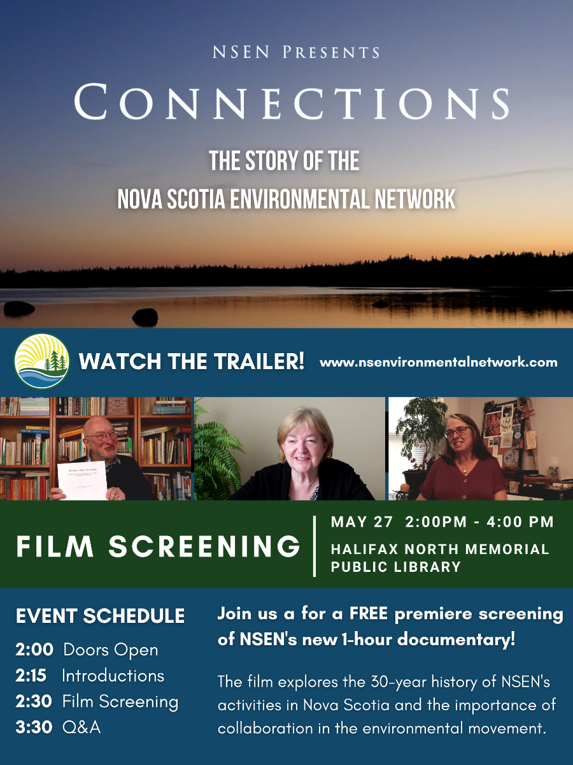

|  |  |
| --- | --- |
| Citizens for Public Justice (@publicjustice) / Twitter | **DEN congratulates**  **Citizens for Public Justice on their 60th Anniversary.**  **We hope your anniversary celebrations are joyful and inspirational.** |



**Greenpeace Petition for a Global Plastics Treat**y

At the end of May, governments from around the world will resume negotiations of a UN treaty that could help turn the tide on plastic pollution. If done right, the Global Plastics Treaty could help address the plastic crisis and its impacts on the world’s ecosystems, animal life, and human health. Microplastics pollution has now even been found in the air we breathe and the food we eat. A global treaty on plastics is what we need. Greenpeace Canada ask us to sign this petition to Prime Minister Trudeau and other world leaders.

**Stop the world's first octopus farm!! (eko.org)**

There is a company in Spain that plans to torture a million octopuses per year. They will raise them in crowded tanks and then kill them by putting them in icy water, which causes a slow, stressful death. This company is planning to do this despite knowing octopuses are highly intelligent and feel pleasure, pain, joy, and fear. Scientists and the media are standing against this plan, and if enough of us add to the pressure right now we can stop them. Please sign this petition going to the Spanish company Nueva Pescanova, calling on them to stop their octopus torture farm.

**Send a Postcard to Cap Oil & Gas Pollution in Canada (cappollutioncards.ca)**

We can fight climate pollution, and a cap on pollution from the oil and gas industry is Canada’s best shot at tackling rising emissions. This opportunity is for us to send a beautiful and meaningful postcard to our MP’s - telling them we support a cap on pollution. Click on the link and then select your climate art for your postcard. Customize your message, share if you like, and send your card to our country’s leaders.

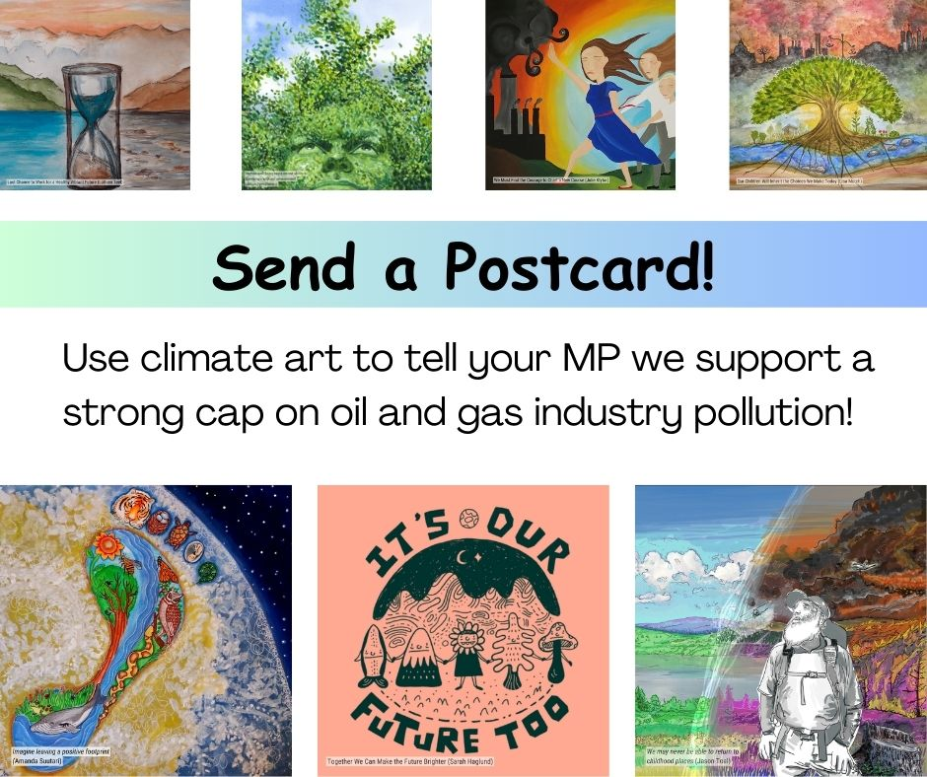

**TAKE ACTION Canada: Protect Earth Defenders in Latin America (amnesty.ca)**

People in Latin America who are working to protect the land, water and forests face an unprecedented increase in attacks and killings. Entire communities can face threats and violence when they talk about the irresponsible logging, mining, and dam projects that threaten the environment they depend on. It’s the most dangerous region in the world to defend environmental human rights. One thing we can do as Canadians is to place effective safeguards to ensure the trade and investment our government promotes in Latin America does not lead to conflict and violence against earth defenders. Add your voice to this petition to urge Canada to be part of the solution.

**Eko Petition against a Timber Giant in Borneo**

Global timber giant Samling is logging Indigenous land in Borneo without consent. When four forest defenders exposed Samling they were slapped with a lawsuit designed to silence and bankrupt them. The timber corporations' logging is also fueling the climate crisis anddestroying the habitats of endangered gibbons, clouded leopards and pangolins. This petiton is asking Samling to drop this lawsuit. The family that owns Samling is worth over $400 million and this isn’t the first time destructive practices have been revealed. A Samling subsidiary has beenfined for bribing forestry officials.



|  |
| --- |
| **Green Stories - Fabric Recycling**  Reduce, Re-circulate, Repair, Repurpose, Collect, Alter, Swap, Donate  Clothing or fabric in general is thrown away at an alarming rate, like 500 million kg a year in Canada alone.  I am leaving links at the bottom for future reading, but those numbers yelled at me.  If we as a Christian group are trying to help this planet, then we should have at least one project that involves fabric.  My first thought was a clothing swap Bring clothes, take clothes, and the rest go to a donation box where more recycling takes place.  The swap could take place in those big underused buildings that have steeples.  How about making a reusable shopping bag from a t-shirt? Bring a teeshirt and we can show you how to make them before you fill the bag with some new duds and leave. Make it all free on even a Sunday afternoon in winter.  If so much is being wasted, let’s do our part to make use of our resources.  The  Think Thrice Campaign program  https://www.cbc.ca/news/canada/british-columbia/textile-waste-recycling-bc-canada-1.6357584  The University of Waterloo fabric recycling facts  https://globalnews.ca/news/9430446/textile-waste-fast-fashion-ontario-research-recylcle/  The National Association for Charitable Textile Recycling  https://nactr.ca  Nova Scotia’s part of https://ns.211.ca/agencies/national-association-for-charitable-textile-recycling/  Waste free https://wastefree.ca/2023/03/  **Garden Tips**  This one I am trying this year. Use corn stalks as a natural trellis for bean plants. I am thinking second planting of beans when the stalks are a good size.  I’m told eggplant grows better in a container so I will try one this year. Till now I set my transplants with my tomatoes and peppers on a sheltered side of the shed.  Can we grow ginger here? I am told to bring ginger inside once it gets below 10C so I feel it can grow from June to September outdoors. That may be a fun new plant to grow.  In the past, I always laid a few bags of topsoil where I want a new garden. I would cut the bag open and tuck the plastic under the soil bag. That first year I would grow shallow things like spinach, lettuce, radish, or even peas and beans. Come fall, pull the plastic bag out and a new garden is ready.  This year I have a dump truck of topsoil in my yard so I won’t be buying more than a bag of potting soil for transplants. I saved the extra heavy cardboard box my rowing machine came in 3 years ago. This year it is starting a garden on the side of the shed. The cardboard will break down by fall but a new garden will be in its place.  More cardboard is being laid down with 6-10 inches of soil on top. Even a new box garden is using cardboard to cut down on heavy digging.  **Reminder Ribbon**  This is so simple that I have one in the shed and one in my office. If you have a wide thick ribbon, a piece of canvas, any stiff fabric, or, dare I say it, a long skinny piece of plastic (like a strip off a plastic tablecloth that is saved for the few times you need a plastic cover. They make a water source slanted off a building to catch dew.).  At the top, I sew a hem or loop to fit over nails I have in the shed (staples work well also). At about 6-inch intervals, I sew a binder clip to the ribbon. clip either paperwork I need to finish or some items I want to easily find. It is a narrow skinny way to hang things up for an easy find. Just showing it off on the freezer door.    My favorite new cook, even if silly at times, is Dylan Hollis. This week he reminded me of Tomato Soup Cake. I found the recipe in my recipe box but the frosting is all his. It is going to be the new favorite to take to pop luck events.  **Tomato Soup Cake**  ¼ cup butter  1 cup sugar  2 large eggs  1 ½ cups flour  1 tsp. baking soda  1 tsp baking powder  1 tsp nutmeg  1 tsp cloves  1 tsp cinnamon  1 can condensed tomato soup  ½ cup walnuts  1 cup raisins  Add the ingredients as they appear, scraping down the sides. Put in a 10 x 13 pan and bake for 25-30 minutes at 350.  **Cream Cheese Frosting**  ½ cup butter  8 ounces (1 pack) of cream cheese  1 tsp. vanilla  2 cups icing sugar  It seems thick but don’t add extra liquid as it will become soft quickly  A picture containing food, table, piece, slice  Description automatically generated    Pin on Everyday Prayers |
|  |
|  |