|  |
| --- |
| **March 28, 2023**  **Email:** **endionspei@gmail.com** **Website:** **nspeidiocese.ca/den**  **Facebook:** **Environment Network Diocese of NS & PEI**  **“To strive to safeguard the integrity of creation and sustain and renew the life of the earth”**. |
|  |







***The People's Parade for Life on Earth!***

You are invited: ***The People's Parade for Life on Earth!***

Earth Day, Saturday, April 22nd (Rain Date: Sunday, April 23rd, 2023)

Organized by the Grassroots Grandmothers, Ecology Action Centre, School Strike 4 Climate Halifax, iMOVe, DEN and others.

A celebration of Mother Earth, connecting and reconnecting us with all of creation and all that is in, on and about it, all our relations. We encourage to use imagination, creativity and expressions of Earth Day joy. (But NO motorized vehicles.) Everyone is welcome!

We gather at 1 pm at the wave on the waterfront. The parade begins 2 pm and ends at the Peace & Friendship Park with a community gathering and celebration.

There are limited funds available to help support participating groups with materials and transportation costs.

Registration: https://docs.google.com/.../1FAIpQLSencOWkzP2dCe.../viewform

If you have any questions contact Joanna Bull at joanna@ecologyaction.ca

We hope to see you there!

**Are your churches planning ahead for Earth Week?**

**For the Love of Creation** encourages us to **plan** **together for Earth Week:**

**To pray:**

-  invite/ask our local communities of faith to focus sacred readings, prayers and messages on loving and caring for the Earth on our designated day/time for worship. Use FLOC worship resources or those of their own choosing. Earth Day Sunday Worship Service – Use in full or in part. (For Christians, these connect Doubting Thomas with Climate Justice.)

**To Learn:**

-  invite/ask our local groups and communities of faith to share, promote the webinar Preserving Biodiversity: Creation Care from Faith to Action, Thursday March 23 at 6 pm

**To Act:**

- Give it up for the Earthdirected to Minister Guilbeault –Sign and Encourage others to sign this open letter for climate justice . **Feel free to use the attached letter**

- Celebrate Earth Day, Saturday April 22nd, with a **People's Parade for Life on Earth!**

**Earth Day Liturgical Resource:**

https://niagaraanglican.ca/uploads/documents/2023/03/2023-cjn-sunday-liturgy-final.pdf



|  |
| --- |
|  |
|  |

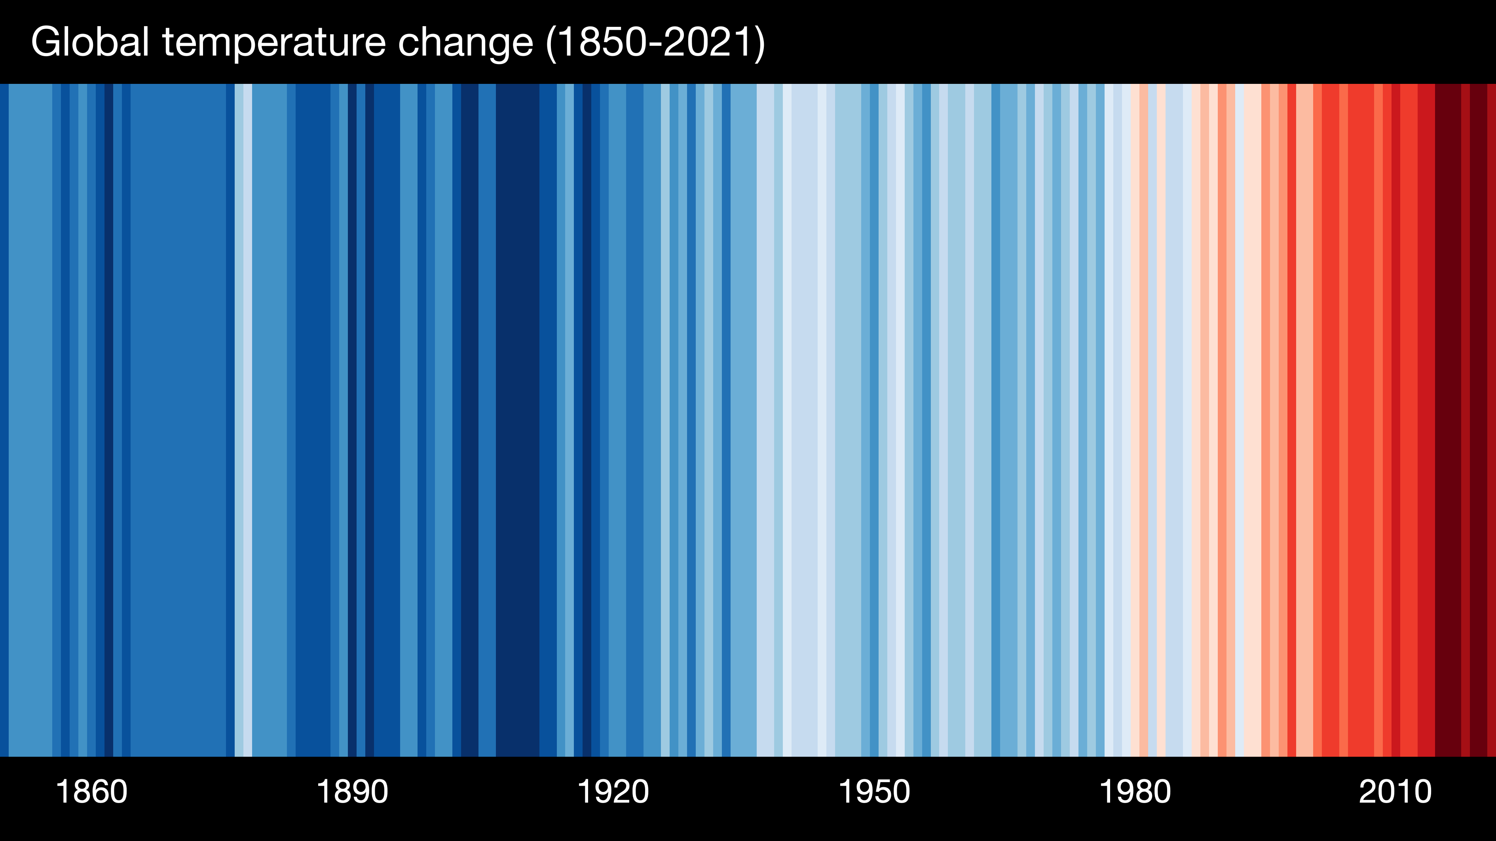

|  |  |
| --- | --- |
| |  | | --- | | The Intergovernmental Panel on Climate Change (IPCC) is the largest body synthesizing global scientific climate change research. Their reports represent global scientific consensus about climate change. As people motivated by our faith, we welcome the knowledge of the scientific community to inform our responses and work for climate justice. Read the Summary of their most recent Synthesis Report, released Monday, March 20, 2023. In a statement this week, UN Secretary General António Guterres said, "We have never been better equipped to solve the climate challenge, but our world needs climate action on all fronts - now. Everything. Everywhere. All at once." Join the many faith communities that are taking action for climate justice during Earth Week (April 16-23, and beyond!) Share your plans with us! See below for more details.  **From our Advocacy Editor, Eva Evans**:  "INTERLAKEN, Switzerland, March 20, 2023 — There are multiple, feasible and effective options to reduce greenhouse gas emissions and adapt to human-caused climate change, and they are available now, said scientists in the latest Intergovernmental Panel on Climate Change (IPCC) report released today."  To see a 3 min video from the IPCC, go to https://www.ipcc.ch/report/ar6/syr/  To read the report go to https://www.ipcc.ch/report/sixth-assessment-report-cycle/ |   F:\0.DEN Enews\Banners\banners upcoming events.jpg  **C:\Users\cayla\AppData\Local\Temp\Website poster GBSNS—New Link.png**  **Our next green burial café is on Wednesday, March 29th at 7:00 pm ADT.   We hope to see you there**.  **Saturday, April 1. Fossil Fools Day**  This April Fool’s Day, don’t fall for RBC’s lies.  The Royal Bank of Canada is the main funder of Coastal GasLink, a fracked-gas pipeline project being violently and illegally forced through unceded, sovereign Wet’suwet’en territory without their consent. This project increases Canada’s fossil fuel infrastructure and jeopardizes the sacred Wedzin Kwa river, supplier of clean drinking water and edible salmon for the Wet’suwet’en Nation since time immemorial.  RBC is also the #1 fossil fuel–funding organization in Canada, #5 in the world. On April 5 they will hold their AGM in Saskatoon, where the Wet’suwet’en hereditary chiefs, land defenders, and allies will confront them. In solidarity with those folks, actions at RBC branches across the country on April 1 will put RBC on alert and remind shareholders and the public that their attempts at greenwashing and lip service to Indigenous consultation are not fooling anyone.  This fight needs your voice! Please come out to the Almon Street branch (corner of Agricola) on Saturday, April 1, at 1:00 to sing, chant, and make some noise with others who care about Indigenous rights and climate justice. We won’t be fooled into believing stolen land, poisoned rivers, and climate destruction are viable investments! Let’s call out RBC as the true Fossil Fools! Register here. |

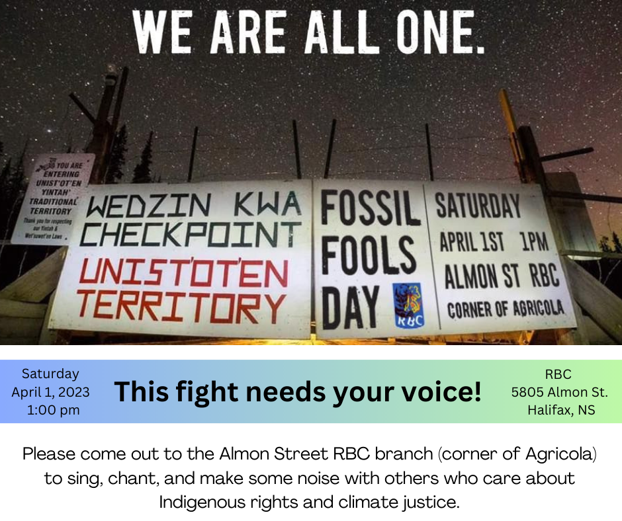

***In New Brunswick:*****Stop the Coastal Gaslink Pipeline and its funding by RBC**

**A nationwide day of action will take place on April 1st****– Fossil Fools Day -2023**

**Moncton event: 1pm outside the RBC Branch at 719 Mountain Rd.**

**Organized by Decolonial Solidarity and Leadnow**

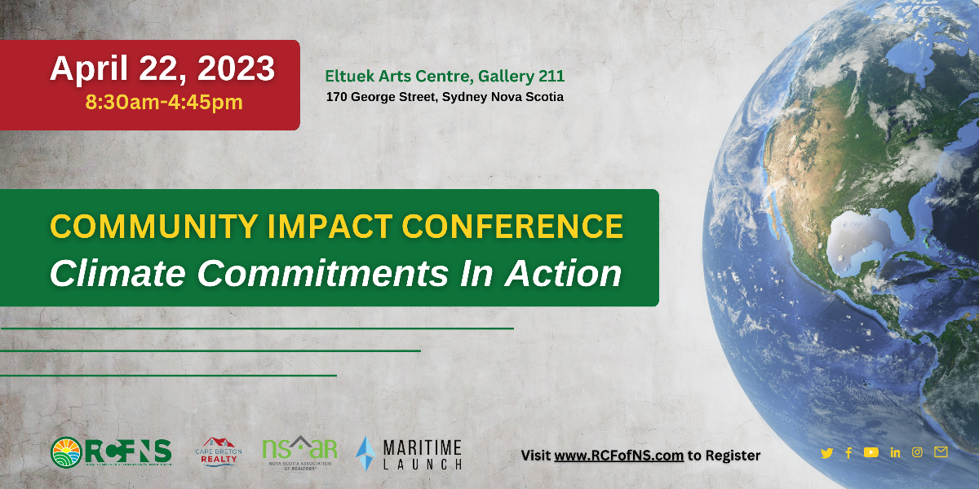

|  |  |  |  |  |  |  |  |  |  |  |  |  |  |
| --- | --- | --- | --- | --- | --- | --- | --- | --- | --- | --- | --- | --- | --- |
| |  |  |  |  |  |  |  |  |  |  |  |  |  | | --- | --- | --- | --- | --- | --- | --- | --- | --- | --- | --- | --- | --- | | |  |  |  |  |  |  |  |  |  |  |  |  | | --- | --- | --- | --- | --- | --- | --- | --- | --- | --- | --- | --- | | |  |  |  |  |  |  |  |  |  |  |  | | --- | --- | --- | --- | --- | --- | --- | --- | --- | --- | --- | | |  |  |  |  |  |  |  |  |  |  | | --- | --- | --- | --- | --- | --- | --- | --- | --- | --- | | |  |  |  |  |  |  |  |  |  | | --- | --- | --- | --- | --- | --- | --- | --- | --- | | |  |  |  |  |  |  |  |  | | --- | --- | --- | --- | --- | --- | --- | --- | | |  |  |  |  |  |  |  | | --- | --- | --- | --- | --- | --- | --- | | |  |  |  |  |  |  | | --- | --- | --- | --- | --- | --- | | |  |  | | --- | --- | | |  | | --- | | **Conference Agenda** | | | |  |  | | --- | --- | | |  | | --- | | **Click Here To Register** | | | | | | | | | | |
| Nova Scotia’s rural communities are directly affected by climate change through such factors as sea level rise, storms, weather, disease and species shift. Nova Scotia’s communities are on the front-lines to adapt to and mitigate the effects of climate change. We have a vital role in finding solutions to this enormously difficult and complex issue.  The Community Impact Conference is being held **April 22, 2023** in Sydney, NS as part of the Rural Communities Foundation of Nova Scotia’s (RCFNS) commitment to climate action. |
| The conference will highlight the work of communities dealing with a wide variety of climate change issues. RCFNS’ intention is to create a circle of informed, innovative problem solvers |



To register:  Noon ADST (4 pm GMT) https://us06web.zoom.us/meeting/register/tZwkdOyppz8rHNKiEe0aZvfg8Xv4RzZDw8Gf



**Fossil Fools Day – April 1st**

This April Fools’ Day, don’t fall for RBC’s lies. The Royal Bank of Canada is the main funder of Coastal GasLink, a fracked-gas pipeline project being violently and illegally forced through unceded, sovereign Wet’suwet’en territory without their consent. They are the #1 fossil fuel–funding organization in Canada and #5 in the entire world!

Are you in the Halifax area? Join this event for Fossil Fools Day: Fossil Fools Day | RBC Royal Bank, Halifax, NS | April 1, 2023 (happeningnext.com)

Find an event in another location here: Fossil Fools Day: RBC Day of Action April 1st, 2023 | Leadnow.ca

**Tell RBC to stop funding fossil fuels (greenpeace.ca)**

With RBC, every day is a climate crisis. In 2019 alone, RBC's support for fossil fuels was 250 times greater than their contributions to community and charitable organizations. They have been funding destructive projects that violate Indigenous rights and fuel the climate crisis, from the Coastal GasLink project to the TransMountain pipeline expansion. They need to divest from fossil fuels and invest in our common future. A first step could be allocating more than a mere 1% of their energy financing to renewable energy. Banks do feel the pressure when the public stands up and uses their voice together to talk about the issues; online, at bank branches, or through petitions. One of the definitions of fossil is a person or thing that is outdated or resistant to change. RBC needs to stop being a fossil. They need to stop being resistant to the changes our world desperately needs. This year for Fossil Fools Day on April 1st, tell Canada’s top fossil bank to stop funding fossil fuels!

**Hold Big Oil accountable for its climate pollution (davidsuzuki.org)**

The March 2023 IPCC report warns that immediate and drastic action is needed to avert irrevocable climate damage. The oil and gas industry is Canada’s largest and fastest-growing source of emissions, and there are currently no limits on the amount of climate pollution it can emit. The federal government must regulate this if we are to meet our climate targets and ensure Canada’s legacy is one of real climate action. Every sector, community, and level of government must reduce emissions, including and especially the biggest emitter: oil and gas. While other sectors in Canada reduce their emissions, the oil and gas industry’s emissions continue to grow. Instead of reducing emissions, they are lobbying to stall and undermine climate action, and failing to clean up the environmental and climate damage they cause. This petition is asking Canada to support an emissions cap regulation with strong compliance mechanisms that result in real and rapid emissions reductions, not hypothetical ones. It asks our country to put the interests of all people in Canada ahead of the profits of a toxic, dishonest industry.

**Canada: Stop Bankrolling Fossil Fuels | Amnesty International Canada**

Burning fossil fuels accounts for more than 70% of global greenhouse gas emissions. It is the primary cause of climate change. The ripple effects endanger the right to life, to water, food, housing, health – the list goes on and on. A rapid phaseout of fossil fuels is necessary, and the industrialized countries who continue to fund expansions of fossil fuels are condemning countless people to the worsening impacts of climate change. Export Development Canada is one of the biggest public financial backers of fossil fuels in the world, directing billions to fossil fuel activity in Canada and other countries. This petition is saying Canada needs to STOP financing fossil fuels!

**ACC, Go Fossil Free! (350.org.nz)**

It’s not only North America that needs to stop funding fossil fuels. ACC in New Zealand is another example. The Accident Compensation Corporation is one of New Zealand’s largest Crown Entities. One of the ways that they pay for the services they provide is through a massive $50 billion dollars of invested funds. They decide where this money is invested, and unfortunately, they continue to invest in fossil fuels. As a public institution, ACC must ensure the money is being managed responsibly. It is no longer ethically or financially responsible to invest public funds in coal, oil, and gas companies. This petition is asking that ACC support their government’s commitment to limit global temperature increases, reduce emissions, and limit the global average temperature increase to 1.5°C above pre-industrial levels. Canadians can add their name to this petition, asking that ACC use public funds to build a healthier future for all of us.



**Rivers to Land**

When I was a girl, every gasoline station gave away “litter bags” They mainly hung on the window cranks (when cars had roll-down windows). Mother always had extra litter bags in the glove box (which was still being used for gloves.) If a gas station had a garbage can, (that wasn’t always the case), I would be sent to “take the garbage out” but more often the litter bag came home.

I wish we had litter bags now, but, that would be encouraging plastic bags again. Maybe someone can make a paper bag with a handle, like little heavy shopping bags

How does trash get into rivers? Humans have this nasty habit where, if not littering, then having trash containers blown over and the contents strewed everywhere.

Less trash on the land means less trash in rivers and in time the oceans.

Several organizations encourage litter clean-ups.

You know my favorite is the Women’s Institute in PEI. This isn’t just a small little event in some rural communities. This is a province-wide event with the government working with a non-profit to do meaningful work to help save the planet.

If 80% of ocean trash comes from the land and the land you live on is an Island; well, it doesn’t get more important than that. The WI saw that, FIFTY years ago.

If a WI member is reading this, save me a yellow bag this year. I would love to have one. If living in PEI, go to your local Access location or just plain get ready to do your cleanup on May 13th.

WI told me “This website is brand new and we are still working a few kinks out. Feel free to contact us at wi@gov.pe.ca or https://www.facebook.com/PEIWomensInstitute for a faster reply.”

Other organizations that support the liter clean-up are.

Right in my own Nova Scotia

https://www.nspickmeup.ca/

Out in Calgary

https://www.calgary.ca/volunteer/litter-cleanup-kits.html?redirect=/tlckits

In Ontario

https://cslgroup.ca/property-maintenance/litter-cleanup/

Pitch In Canada

https://pitch-in.ca/programs/pitch-in-canada-week/

If I wasn’t working on Community Gardens on Earth Day, we would be doing a Litter Clean up. Hummmmm, Maybe we can do one later in the summer.

**Editor’s Note: This Facebook page chronicles one woman’s journey cleaning the Bay of Fundy shoreline…Every Day! Please take a look – it’s a real eye-opener what comes up the eastern seaboard to land on our shores.** **https://www.facebook.com/kleanitup18**

**GARDENING TIPS**

This week I heard some neat tricks for my hoes and rakes.

I paint all my hoes, cultivators, and forks either white or yellow (according to what I have left in the paint can.) Besides finding your tools on the ground easier, it can also be seen as safety prevention.

My friend Mike disliked carrying his tools from one part of the yard to another. He found a golf bag on wheels and put his tools in the bag and filled up the outside pockets with the small things we use for gardening. This could be pulled from one spot to another and allowed him to have whatever he needed wherever he was working. At the end of the day, the garden golf cart was pulled back into the shed.

(He also removed the motor from an old lawn mower so he had a flat space on wheels to roll his generator in and out) Editor’s Note: Ingenious!

A very useful tip is to use a permanent marker and mark off in inches or cm., down the length of your hoe. If a plant needs transplanting 4 inches apart, you have your measuring stick with you.

|  |  |
| --- | --- |
| **Bottle top Craft**  Some of you may remember the time when my Parish saved bottle caps. Nana Lorn and I would fill the Green Spark with bottlecaps that were only saved at the Blandford Community Centre. I mean filled the car to its roof and usually had a bag at my feet till we got to Eastern Passage.  The collection agency told us the project was closed but it took a year to get through to the Parish that it had stopped. I still have 3 bread bags of caps in a garden shed and a couple in my basement.  I am so glad I have them, because look what I found to make. WOW !  I am thinking these may add to the yard decor and possibly scare the deer from the gardens.  Read the How To Make them at https://craftsbyamanda.com/recycled-plastic-lid-windchime/#wprm-recipe-container-22495 | Recycled wind chime made from plastic lids |

|  |  |
| --- | --- |
| **Something to eat**  It is getting to that time of year when one dreams of BBQing, if we don’t have our cookers outside the garage yet. I found ribs at the grocer this week and made my first batch of Homemade BBQ sauce. If you like it, double or triple the recipe, put in mason jars, put lids and screw tops on finger tight and boil 20 minutes and you have a summer load of BBQ sauce. Want to get more inventive, wait till the tomatoes you grew ripen and make your sauce from fresh tomatoes | .  **Barbeque Sauce**  2 cups ketchup  2 tbsp brown sugar  ½ cup honey  ½ cup vinegar  1 tbsp Worchester (steak) sauce  Dash of lemon juice  A few drops of hot sauce  A seasoning mixture, be it Montreal or Stonehouse, etc.  Mix and use (immediately). Leftovers are good in the fridge for 2 weeks, otherwise, put them in mason jars and a hot water bath for 20-30 minutes. Good on anything you put BBQ sauce on. |



### **Fossil Fuel Prayer**

Holy Spirit, you hovered over the deep,  
and you know the deep problems we face today  
around energy and fossil fuel consumption,  
and the way this conflict gnaws at the church.  
We live in a cold country, we need to keep warm.  
Our homes are heated with oil and gas.  
Help us find efficient and affordable ways  
to keep ourselves warm.  
We are people on the move; thank you for new technologies  
that reduce our consumption of fuel,  
help them become more accessible for the average person.  
Thank you for oil workers who work outside in difficult conditions  
so that we have the fuel we need to live.  
Thank you for environmentalists who challenge us  
to think outside the fossil fuel box.  
Preserve us from the power of big corporations  
who think only about profit and the bottom line.  
Give wisdom to our politicians as they make decisions  
that are good for us, and for generations yet unborn.  
Much has been accomplished in this age of oil,  
and much harm has been done;  
the effects of climate change impact us all.  
Forgive us our sins where we have been wasteful,  
and show us how to live differently.  
Equip us to be true stewards of your earth,  
mindful of the needs of our sisters and brothers  
and the creatures of the sea, the sky, the land.  
The earth is yours, and all that is in it,  
we worship you alone.  Amen.

https://carolpenner.typepad.com/leadinginworship/2019/06/fossil-fuel-prayer.html