|  |
| --- |
| **March 14, 2023**  **Email:** **endionspei@gmail.com** **Website:** **nspeidiocese.ca/den**  **Facebook:** **Environment Network Diocese of NS & PEI**  **“To strive to safeguard the integrity of creation and sustain and renew the life of the earth”**. |
|  |



**Look what was in ACEN’s Latest Newsletter!**

**We were!**

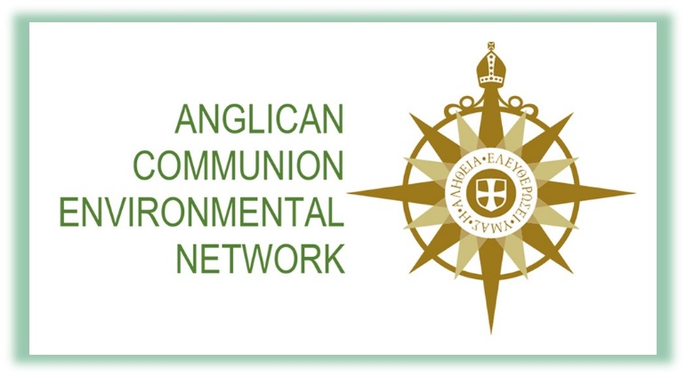

|  |
| --- |
| Introducing the Environment Network of the Canadian Diocese of Nova Scotia and Prince Edward Island We have been remiss in not introducing you readers to one of the ACEN’s longest running partner networks.  Checkout their Facebook Group HERE.  Check out their YouTube Channel HERE  https://mailchi.mp/c63444f97487/lambeth-conference-and-season-of-creation-5389266?e=0dd67e46dd  F:\0.DEN Enews\Banners\banners Climate Cafe.jpg |

Next Climate Café will be at Christ Church, Ochterloney St. Dartmouth this Thursday, March 16th – 7 pm



“Let Justice and Peace Flow” is the theme chosen for Season of Creation 2023, the ecumenical celebration held each year from September 1, World Day of Prayer for the Care of Creation, to October 4th, the feast of St. Francis of Assisi. For more information: https://seasonofcreation.org/ or contact the Dicoesan Environment Network at endionspei@gmail.com

F:\0.DEN Enews\Banners\banners World Water Day.jpg



What are you doing for World Water Day, Wed. March 22 and beyond? The UN 2023 campaign is now live with the theme *Be the Change*. It encourages people to take action to change the way they use, consume and manage water.

* To find out more about World Water Day 2023, click here.
* To make your own Water Action list, click here.
* To check out the Lazy Person’s Guide to Saving Water, click here.
* To find more simple #WaterActions you can take, click here.

Worship Resources are available from the Canadian Foodgrains Bank to use on Sunday March 19th: https://foodgrainsbank.ca/resources/world-water-day/



|  |
| --- |
| https://secure.kairoscanada.org/sites/secure.kairoscanada.org/files/civicrm/persist/contribute/images/uploads/static/EarthWeekLogoEn_fd394478602ed7a85b2927070a616557.jpg |
| |  | | --- | | **Let’s make hope visible across the country** | |  | | On Earth Day in 2020, KAIROS Canada, faith bodies and faith-based organizations in Canada came together to launch **For the Love of Creation**. This national initiative is a unified banner to mobilize education, reflection, action and advocacy for climate justice. It is faith based and theologically grounded, centres Indigenous self-determination and youth empowerment.  Three years in, we invite all faith communities to be part of the movement and join with faith communities across the country in:  **Earth Week 2023 - Together for the Love of Creation**  **During the week of April 16 - 23, engage in a climate justice activity…praying, learning, acting.**  Coming together for the love of creation is a way to connect, grow, listen, inspire hope and affect change. Your activity could be visibly joining a community-wide event or creating something new. This is a chance to reach out to other faith communities and neighbours in your climate justice initiatives.  Mark Earth Week in a way that reflects and challenges your community. Some ideas to get you started…   * **Praying:** Include special prayers in your service. Hold a prayer service in creation. * **Learning:** Hold an open house to share the greening efforts on your property. Host a Faithful Climate Conversation. Invite a speaker (e.g. a youth or Indigenous COP delegate, or a local Indigenous land or water protector) * **Acting:** Meet with elected officials about climate policy. Organize a collective carbon footprint audit. Participate in Indigenous-led land based activity   **Please add your activities to the For the Love of Creation Earth Week 2023 map, as soon as possible:**  https://fortheloveofcreation.ca/earth-week/  F:\0.DEN Enews\Banners\banners Greening Sacred Spaces.jpg  Faith and the Common Good has created a Certification program as a measurable way to motivate action, receive recognition for your greening efforts and celebrate your achievements. To find our more: https://www.faithcommongood.org/certification?utm_campaign=ed_newsletter_march_2023&utm_medium=email&utm_source=faithcommongood  F:\0.DEN Enews\Banners\banners Webinars.jpg | |  |   **March 19th. Wet'suwet'en Land Defenders and the RBC Annual General Meeting**. RBC is a huge funder of fossil fuels and the webinar’s focus will be to learn directly from theland defenders about their home and culture, and what we're all fighting to defend. Then discover more about how you can help draw attention to the issue at the upcoming RBC AGM.  **Please register for the 19th of March, 19h ET, to learn or rediscover what we are fighting for.** |
|  |



**Webinar: Community Energy & Energy Democracy**

**Find out more and register for this March 23rd webinar:**

https://beyondclimatepromises.ca/community-energy-democracy/



The community-proposed Ingram River Wilderness Area would protect over 15,000 hectares of publicly-owned forests and waterways draining into St. Margarets Bay. These former Bowater Mersey lands encompass dozens of undeveloped lakes, brooks, and still waters that connect its remote interior to the ocean. Although degraded from years of logging, it is an incredible place where nature hangs on and is ready for a comeback. The area still harbours expanses of intact forest and pockets of old growth (along with lots of regenerating clearcuts). With time, given a chance, it can recover and provide a multitude of benefits for the environment and our quality of life.  Protection as a wilderness area will provide a clean break from the days of resource exploitation, putting these lands on a new path toward recovery and restoration without the constant threat of more logging and other industrial activities. https://www.protecttheingram.com/?fbclid=IwAR26Knm019xJ3HmDjw096_OkplcurUmbRQfHkYNKHVeFhxQIY4xTZAL4sQ

We

**Environmental Defence Canada**

There is no way around it; the Canadian government must stand up to the oil and gas industry and end fossil fuel subsidies. For decades, oil and gas companies have profited immensely from activities that fuel the climate crisis and pollute our land and water. These wealthy companies use their influence to extract tax breaks and handouts from our government. This takes away funds for public services while making it cheaper to pollute. Pressure from Canadians has led to the federal government making promises to eliminate subsidies by the end of 2023. Any pay-out to industry qualifies as a subsidy.  We can take action by telling the federal government to stop using our public dollars to finance pollution, environmental destruction, and injustice.

**Petition · Biden Administration and ConocoPhillips: SAY NO TO THE WILLOW PROJECT! · Change.org**

This petition is having an impact and receiving a lot of recent media attention. That’s because millions of everyday people have been signing it, all saying to stop the Willow Project! This development project in Northern Alaska is proposed by ConocoPhillips, a company surrounded by controversy for continued oil drilling, exploitation of nature, and posing risks to Indigenous communities globally. The project came from the Trump administration, but now it is Biden’s that will soon decide whether to approve it or not. The Willow Project would represent the biggest new US oil field in decades and would emit more climate pollution annually than almost any other single point in the country. By the administration’s own estimates, the project would generate enough oil to release 9.2 million metric tons of planet-warming carbon pollution a year – equivalent to adding 2 million gas-powered cars to the roads or to burning nearly 51,000 rail cars worth of coal. Studies are showing the Arctic is warming at four to five times faster than the rest of the world. Approving the Willow Project would be a foolish and disastrous decision for everyone. Sign your name to tell Biden and ConocoPhillips that the answer is no.

**Petition · Greensville Opposes Burning Waste in Kilns · Change.org**

Carmuese is a Belgian company on Hwy 5 in Hamilton, Ontario. This company is planning to burn waste in their kilns. It claims it wants to lower the cost of the fossil fuel they presently use and burn waste to lower Co2 emissions. The waste they will burn will include plastics, rubber, nylon, wood, and other materials they classify as Non-Recyclable Waste. This will release different toxic and harmful chemicals, carbon dioxide, and other greenhouse gasses into the atmosphere. The local community is opposed to the burning of waste, from the possible human health effects it will have to the degradation of the environment. They aren’t getting answers from this company though and they could use a hand from other Canadians to create some public pressure. This petition is going to the local MPP.

**DRC: Release the palm oil protesters jailed in Mwingi! - Rainforest Rescue (rainforest-rescue.org)**

Petitions like this are important because they give a global voice to people or causes who don’t regularly make it to the world stage. There are communities in the Democratic Republic of the Congo who have suffered for decades under palm oil companies. These are people who have lived on the land for countless years, but now the land is owned and transferred around by multiple foreign companies, even a Canadian one. The communities demand the return of their land, land they haven’t been able to use for over 100 years and that wasn’t taken without consent. The companies have all the power here and the communities face violence when they try to protest. They are arrested and then experience serious abuses in jail. Local people are being harassed, attacked, forced to flee their homes, and even killed over accusations of stealing a palm fruit. The conversion into industrial plantations has harmed forests and wiped-out areas the size of New York City. This petition is a way to give these people a louder voice. It is demanding the release of the palm oil protestors and an end to the violence and land grabbing.



**OCEANS - The Great ATLANTIC Garbage Patch**

Water is one if not THE most important thing we need as human beings. Having clean water starts with rain which flows into brooks which flows into rivers, which empty into the oceans.

Eighty percent of ocean trash comes from the land and in our case ends up in the GREAT ATLANTIC GARBAGE PATCHE(S). (We often hear of the Pacific one that is bigger than the state of Texas and mainly floats between California and Hawaii.)

Our Garbage Patch doesn’t make much news probably because it swirls in a larger area and keeps moving with ocean currents.

The highest concentration is in the Sargasso Sea. Most Seas have boundaries of land, but the Sargasso Sea is bounded by currents. The Gulf stream is on its west side and the North Atlantic current is on the North. The Canary (Islands) current is on it’s east and the North Atlantic Equatorial current on it’s south. The currents keep spinning around the Atlantic Ocean and with it spins the trash.

A unique seaweed grows in the Sargasso Sea; one that likes to collect whatever brushes up against it. There are stories written how hundreds of years ago this seaweed at least slowed ships if not trapped them within their boundaries.

Now this to get a feel of the size of the Atlantic Garbage Patch consider it is said to be hundreds of km long wide (just *wide*). Prince Edward Island is 280 km LONG so picture something at least the length of PEI floating out in the Atlantic, thousands of km long.

An inshore fisherman friend of mine tells me of tiny patches he has seen, maybe 50 to 100 feet across, just off our shores. He has seen them grow as he passes them daily until a storm breaks them up and then they start to grow again. He can actually see how they develop.

So where does all this trash come from? No one goes to a shore and dumps their trash bags in the water so how does it get there?

It goes right back to not being a litter bug; to keeping our lands and ditches clean of litter.

Meanwhile back in the ocean what is being done to help? That would involve a book’s worth of information. My purpose today is just to let you know we have our own Great Atlantic Garbage Patch. Our planet needs our help to keep our oceans healthy.

It is hard to find pictures of the Atlantic garbage Patch. All the news is about the Pacific one which is bigger than the state of Texas now. Just in case you didn’t think it was something to be concerned about, here is one picture of the Atlantic one from space courtesy of https://en.wikipedia.org/wiki/North_Atlantic_garbage_patch

See where Nova Scotia is? See how big our patch is? I am presuming that green is everyday plastics trash and red is a high concentration of micro plastics that are known to be denser nearer the Canary Islands to Africa. That needs more study. Either way there is a big garbage patch in the Atlantic, much bigger than PEI.

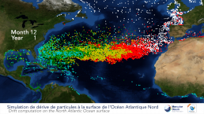

https://www.wired.com/2010/08/atlantic-plastic/

http://www.oceansplasticleanup.com/Cleaning_Up_Operations/Cleaning_Up_Oceans_Seas_Projects.htm

To find general Ocean Garbage Patches info just plug words in a search. I like to click on images or videos and just get a general feel of things before diving into a search.

A great Earth Day project is to clean a beach or a section of road and keep trash from getting into the ocean in the first place.

Next week we will see some neat ways to prevent trash from getting in the ocean.

**Editor’s Note:** To see visual evidence of what Grandma is talking about, check out this Facebook page – Nova Scotia Beach Garbage Awareness. Your eyes will pop! https://www.facebook.com/kleanitup18

**Gardening Tips**

I heard this week that someone has a wooden box filled with sand. She sticks all her small gardening tools in the sand and they don’t rust. Why, I thought, as sand to me is full of salt off the beach a few feet away. This is the non salted construction sand. Keeps everything dry and reduces rust.

Coffee filters in the bottom of hanging planters or any plant pot lets water out but keeps soil in.

If you have any plastic forks, stick them upright in your garden to keep critters out. Rodents stay away from tined objects. Good row marker to if you cut the side of a yogurt tub and twine it in the forks.

Now here is my favorite for the week. Pretend I boil a pot of carrots and turnip to mash together for supper. Instead of pouring the water down the sink, I save it for a soup. One step more is to save the water and pour it on your garden for fertilizer for the existing plants. It also waters the plants when wells start going dry. I think I am going to find a big bottle and save all that waste water this summer for the garden.

**A Raft Craft**

This craft let me get outdoors for a bit and prune a few willow branches to use for the raft. Any type of little branches would do.

You might want to cut a few branches off your forsythia and bring them in the house. Stick them in water and they will bloom in a couple of weeks and make it feel like spring.

Cut twigs the same size and tie them together, two at a time.

The picture shows two rows but I added a row down the middle

Now what about a sail? We need to jam one or two sticks in the middle of a side and lash it tight.

As my sail was an attempt at a jib sail running bow to stern. I added a rope loop at the back to tie it in place. You could just as easily have one square foresail on your raft.

Now how much weight will a raft hold?. Fill up a sink and keep piling heavy things on it till it sinks or dumps its load, so it floats again.

Make a bigger raft and try again with a brick, Grandma’s painted stones, even a hammer balanced head down.

What if you added pieces of Styrofoam to the twig raft. Is it harder to sink? How would you join Styrofoam to the twigs?

Endless questions and procedures with a bit of wood and string and a kitchen sink. Try it next time they are bored.

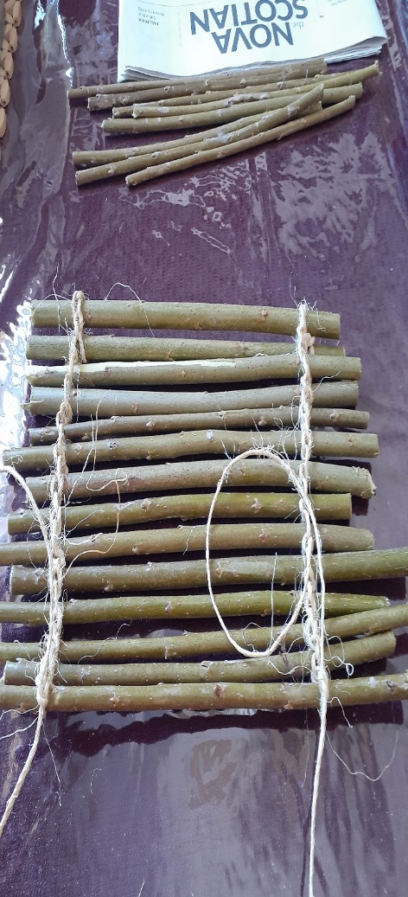 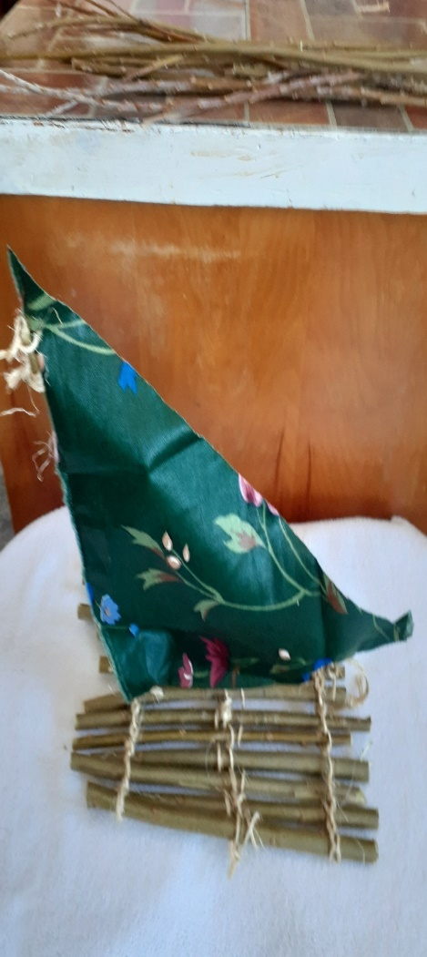

**Small Batch Bread inside an hour**

Did you ever have that meal that a fresh roll would be so good to have with it? You want a bread and molasses dessert. Making bread usually falls into that day long process or at least a long morning. When I heard of 45-minute bread I was skeptical but had to try. I say it takes 45 minutes, but maybe I am slower than some. Either way, if you are making a full dinner there is plenty of time to have fresh bread.

Let the yeast proof, add flour and make 4 buns to rest 10 minutes and bake

**Small Batch Rolls**

½ cup warm water

3 tbsp oil

1 packet of yeast

A shake of sugar and one of salt

Let froth and add 1 ½ cups flour.

Immediately make 4 buns and put in a little dish. I used a single layer round cake pan. Let rise 10 minutes and put in a 350 oven for 10-15 minutes. (Bread should sound hollow and be brown on the bottom when baked0

This is too small for me. Making a couple dozen rolls and freezing the extra works better in my house, **BUT**, if I want to have a couple people in to learn how to make bread, this is **PERFECT**. Everyone could go home with 4 rolls they made, and the class is about an hour or so long.

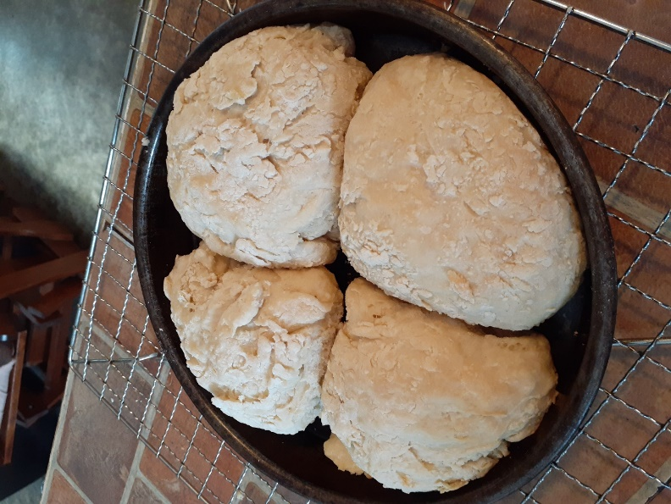

Always welcome ideas here at DEN. Can always reach Grandma at claudiaazinck@gmail.com



**Prayer of Thanksgiving**  
Creator God,  
whose Spirit moved over the face of the waters,  
who gathers the seas into their places  
and directs the courses of the rivers,  
who sends rain upon the earth  
that it should bring forth life:  
we praise you for the gift of water.

Redeemer God,  
who spared Noah and creatures of every kind  
from the waters of the flood,  
who led your people over dry land through the sea  
and across the Jordan to the land of promise,  
who marks our adoption as children with the sign of  
water: we thank you for the gift of water.

Sustaining God,  
create in us such a sense of wonder and delight  
in this and all your gifts,  
that we might receive them with gratitude,  
care for them with love,  
and generously share them with all your creatures,  
to the honor and glory of your holy name.

- The Prayer of Thanksgiving: Living Water (“In the dry wildernesses of  
our lives”) comes from the Sacredise website, and is copyright © John  
van de Laar. www.sacredise.com

file:///F:/0.DEN%20Enews/world-water-day-2021-oymlfi.pdf