Holy Trinity Emmanuel Anglican Church
30 Alfred Street
Dartmouth NS B3A 4E9
902-463-3713
holy.trinity.emmanuel.dartmouth@gmail.com

Priest in charge: Rev. Marian Lucas-Jefferies
Licensed Lay Ministers: Alphonse Lefrense
Joanne Dooley
LAST SUNDAY AFTER PENTECOST
THE REIGN OF CHRIST
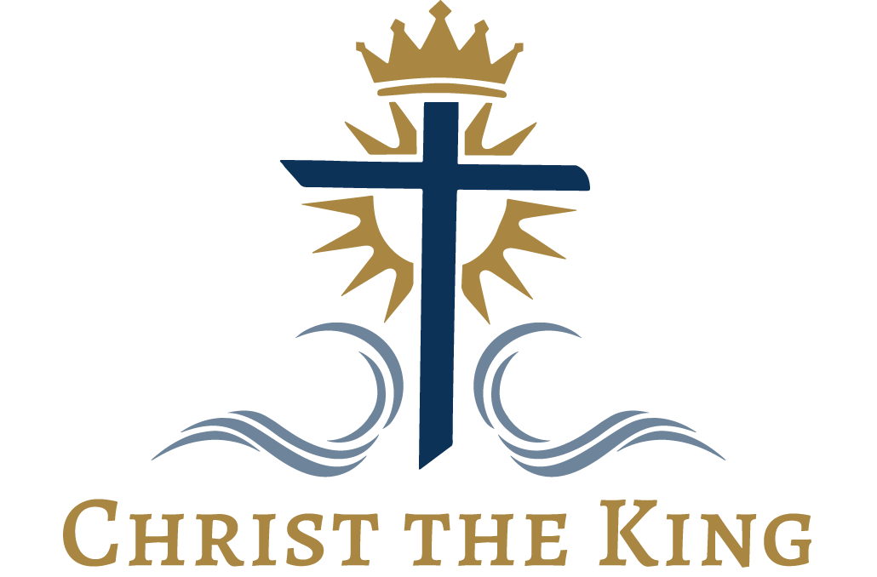

WHITE RIBBON SUNDAY
20th NOVEMBER 2022
Holy Eucharist lead by Rev. Marian Lucas-Jefferies
Music: Alphonse

We acknowledge that we are in Mi’kmaki, the ancestral and unceded territory of the Mi’Kmaq who have been living on these lands since time immemorial. Recognizing this is a small but meaningful step in reconciliation and the continued efforts of building a strong Nation-to-Nation relationship, as we are all Treaty People.

Mission Statement
We are a welcoming Community, a people of God. Together we will live the Gospel through our Worship Services, Fellowship Programs and Outreach Ministries.
Clothing Depot Mission Statement: Serving the community, offering a welcoming, respectful, caring environment to all those who are important to us, those who use the clothing depot, those who donate and those who volunteer, offering quality clothing at no cost.
Order of Service:
Opening Hymn : CP 370 Songs of Praise the Angels Sing
The Gathering of the Community
Glory to God
Kyrie Eleison
1st Reading Jeremiah 23:1-6
Canticle 19a
2md Reading: Colossians 1:11-20
Gradual Hymn: CP 391 Sing ye Praises to the Father
Gospel : Luke 23:33-43
Homily
Apostles Creed
Prayers of the People
Confession and Absolution
The Peace
Offertory Hymn: CP 374 Alleluia Sing to Jesus
Eucharist Prayer The Lord’s Prayer Sung
Breaking of Bread
Communion
Prayer
Blessing
Announcements
Recessional Hymn: CP 327 Lo, God is Here Let Us Adore
Dismissal

Announcements

Please note: If you have announcements or special prayer requests you would like included in the bulletin, please let me know. The cutoff for requests is Thursday at noon . You can either email me at lynno@eastlink.ca or phone 902-464-5697.

White Ribbon Sunday was initiated by the Anglican Church Women Board, Diocese of NS & PEI. The board chose Christ the King Sunday as White Ribbon Sunday to coincide with the 16 Days of Activism Against Gender-Based Violence. Christ the King Sunday is the last Sunday of the Liturgical Calendar year and the Sunday before the First Sunday of Advent.

November Services and Activities
20th The Reign of Christ & White Ribbon Sunday
25th Takeout Soup or Sandwich Lunch : 11am-1pn Soup choices: Chicken with Rice, Chili or Corn Chowder with roll & cookies $7.00
Sandwich choices: Egg Salad on white or whole wheat, Ham & cheese on Rye, white or whole wheat with cookies $5.00
We are looking for soup makers and cookie bakers for the new year. If this is something that is of interest to you, please see Lynn
26th Drama Club 1pm Church Hall
27th—First Sunday of Advent
Personal Care Items for the Dartmouth North Foodbank must be in.
Parish Council—following our time of worship. Please have reports to Paulette by Monday Nov 21st.
29th Faith Brewing 7pm Ship Victory 400 Windmill Rd

Christmas Projects :
This year we again will be supporting the 2 Food Banks in our Area:
The North Dartmouth Outreach Resource Center Food Bank (Stairs Memorial): We will be collecting personal care items for their hampers. There is a list of items they are looking for on the table at the back. DEADLINE IS ; November 27th .
The Dartmouth North Christian Food Bank ( Farrell St) We will be sponsoring families again this year, We now have our families! The Angel Tree is up for anyone wishing to take an angel and buy a gift. Please record your name and angel number on the sheet of paper. We will also be providing the non perishable foods for the hampers/ A list of food items needed is on the table at the back All gifts and food need to be in by Dec 4th.If you have any questions, please see Lynn

Raffle Ticket Fundraiser: Prize: 1st prize $500. In gift cards.
Cost $2.00 each.3 for $5.00 Draw date: December 11th

We are looking for people to sell tickets. Please see Paulette if you are able to help out.

Clothing Depot: Wed. mornings 10 - 12 Holy Trinity Emmanuel.

Outside Announcements & Activities

North Dartmouth Echo Fundraiser: Raffle Tickets on a Folk Paining-Lighthouse. Tickets are $2.00 each/3 for $5.00. Please contact Sylvia Anthony 902-463-5806 for tickets.
----------------------------------------------------------------------------------------------------
Sunday 4 December 2022 5 pm tea, coffee, and bring your own meal
6 pm Advent Readings, Christmas Bible readings, and, live music from Triple Image

St. Andrew’s Anglican Church, 8 Locks Road, Dartmouth, will, once again offer a relaxing evening of beautiful music by local trio, Triple Image, and readings from various members of the Advent story, along with relevant bible readings. Triple Image consists of Philip Amirault, Susanna Morash Kent, and Edward Barnstead.

The next part is a bit difficult, as we are not (yet) comfortable suggesting a pot luck meal before the service as we have done in the past. But we can offer tea and coffee, and various cold drinks. Those who wish to “break bread” together could bring their own snack/meal and enjoy it in the hall, appropriately distanced.

LOOKING FOR BRAVE SOULS TO OFFER ONE OF THE READINGS …

The next part is a bit more challenging. We need six brave individuals to read one of the characters story. The entire script is below, so if you have even the tiniest interest in generously sharing a story, you can take your pick. Please let me know if you are willing to read one of these stories on the evening of December 4. And, thank you so much
Martha Barnstead hm 902-435-4957, cell 902-483-6135
St. Andrew’s Anglican Church 902-435-2987

Note from Lynn: If you would like a copy of the script, please let me know and I will e mail it or print it for you.

.potatoes, vegetables, gravy, cranberry sauce, roll & dessert. Pick up 4pm-5:30pm Orders must be placed by Dec 4th For further info-please see the poster on the bulletin board

Parish Contacts

Priest-in-charge
Rev. Marian Lucas-Jefferies 902-483-6866

Parish Administrator
Lynn Orton 902-464-5697 or 902-412-0497

Wardens & Licensed Lay Persons
Alphonse Lefrense 902-464-4736
Joanne Dooley 902-441-8066 or 902-461-9481

Altar Guild
Kay Gammon 902-462-1762

Hall Rentals
Paulette Rogers 902-461-9481 or 902-225-0792

Clothing Depot
Sarah Mackay 902-469-0937

